

THE OKLAHOMA PIPELINE ENERGY STORAGE SYSTEM (OPESS) Trade Study Report

By Jonathan Grinnell

FALL 2022



EN.645.800

Mentor Robert Krzystan

|  |  |  |
| --- | --- | --- |
| Document Name | Date | Reason for Change |
| Grinnell TS | 9/2/22 | Initial Document |
| Grinnell TS_A | 9/16/22 | New Revision was made so that the TS could be updated with professor suggestions. |
| Grinnell TS_B | 9/18/22 | Removed Random Blank Page below the TOC |

Contents

1 Trade Study Report Description 4

2 OPESS ConOps 6

2.1 System Need 6

2.2 System Block Diagram 6

2.2.1 OPESS Block Diagram 7

2.2.2 ESS Block Diagram 7

2.2.3 CaCS Block Diagram 8

3 Trade Study 10

3.1 Selection Criteria 10

3.2 Utility Curves 11

3.3 Trade Study 14

3.4 Sensitivity Analysis 15

4 Functional Changes 16

5 Requirement Analysis 17

5.1 Motivation for Requirement Update 17

5.2 System Requirements 19

5.3 Requirement Verification 19

5.4 Key Performance Parameters 20

5.5 Requirements Metric 21

6 Earned Value Management 22

6.1 Schedule 22

6.2 Milestones 22

6.3 EVM 23

6.4 CPI and SPI Index 24

7 Risk 24

7.1 Risk 1: Weather 25

7.2 Risk 2: Earthquake 25

7.3 Risk 3: Residual Natural Gas 26

7.4 Risk 4: Cyber Security 26

8 References 27

Appendix A: Sensitivity Analysis 28

Appendix B: Verification Cross Reference Matrix 33

Table of Figures

Figure 1: OPESS Block Diagram End of TS Version 7

Figure 2:ESS Block Diagram End of TS Version 8

Figure 3: CaCS Block Diagram End of TS Version 9

Figure 4: URL Filtering Utility Graph 11

Figure 5: Intrusion Prevention System Utility Graph 12

Figure 6: Transport Layer Security Utility Graph 12

Figure 7: Distributed Denial of Service Utility Graph 13

Figure 8: Antivirus Utility Graph 13

Figure 9: Schedule 22

Figure 10: CPI and SPI Index 24

Figure 11: Risk 1 Weather 25

Figure 12: Risk 2 Earthquake 25

Figure 13: Risk 3 Residual Natural Gas 26

Figure 14: Risk 4 Cyber Security 26

Table of Tables

Table 1: MOE Summary 4

Table 2 List of Solution Needs 6

Table 3: Selection Criteria 10

Table 4: Trade Study 14

Table 5: Trade Study Sensitivity Analysis 15

Table 6: VCRM with new and updated requirements 17

Table 7: Requirement Type 19

Table 8: Verification Method 20

Table 9: Key Performance Parameters 20

Table 10: KPP Description 20

Table 11: Requirements Metric 21

Table 12: Milestones 22

Table 13: EVM 23

Table 14: Sensitivity Analysis 1 28

Table 15: Sensitivity Analysis 2 29

Table 16: Sensitivity Analysis 3 30

Table 17: Sensitivity Analysis 4 31

Table 18: Sensitivity Analysis 5 32

Table 19: VCRM 33

# 1 Trade Study Report Description

The **Trade Study Report (TS)** will be delivered as the fourth delivery of the **Oklahoma Pipeline Energy Storage System (OPESS)**. This report will be composed of a Concept of Operations as well as an analysis of a trade study performed. Additionally, a requirement analysis will be present in this document as additional requirements were developed or modified as a result of the trade study. Schedule, EVM and CPI/SPI will also be discussed during this project. The risks first detailed in the OPESS proposal will be updated with any risk reduction efforts that were performed in the functional development phase of the OPESS Project.

The concept of operations will provide a description of the functional need that the OPESS aims to fill. It will focus on spelling out the current makeup of the Oklahoma power grid, its increasing reliance on renewable sources of energy and why a new energy solution will be needed to meet future demand. After that, the ConOps will dive further into the design of the OPESS system through the use of block diagrams in an attempt to flesh out the two subsystems that compose the OPESS.

The trade study discussed during this report was the result of cyber security subject matter expert interviews conducted during the RAR portion of the OPESS development life cycle and the requirements that resulted from that interview. The requirements provided defined the functionality that would be required of any particular solution. During the trade study analysis, it was noted that some capability should be included that was ignored during the initial requirement development phase. Additionally, some of the requirements were found to be overly complex and were broken down in this phase. A few functions were deleted as a result and one was modified in CORE. Full updated requirement and functional traceability can be found in attached appendixes.

This document will also provide an update of the EVM as it stands as of this writing. Schedule updates, deliveries, the WBS and SPI/CPI will be discussed in this section

Risks will be the last real section of the TS. In this section, the risks outlines in the initial proposal will be updated and new risk reduction techniques developed during the requirement development stage will be taken into account.

Lastly, several appendixes will be attached to this document. These appendixes will be a listing of requirements, functions and a cross reference matrix. Since this is fairly long winded and not written in a form conducive to a report, it was thought best to keep it in a separate format for reference purposes.

These appendixes consist of reports generated from CORE. Requirements, function and traceability are all present and verifiable there. The information listed includes requirements, functions, EFFBD interface diagrams and N2 charts. Finally, in Appendix D, all functions are listed out with the requirements they represent as well as the input and output of that particular function.

All KPP’s listed in section 3.5 trace to MOE 2 through MOE 4. These MOEs can be found in the table below. These remain unchanged from the RAR.

Table : MOE Summary

| MOE Number | Summary |
| --- | --- |
| MOE 1 | The energy efficiency of the OPESS must be high enough to be of worth to the market. |
| MOE 2 | The ESS must be able to store energy on the time span of months to years. |
| MOE 3 | The OPESS much adhere to proper cyber security standards. |
| MOE 4 | The ESS should be able to stand up to the elements. |
| MOE 5 | The OPESS must not produce carbon emissions. |

MOE 1 was left was not referenced by the KPPs since that particular MOE is really more of a market and financial requirement. This MOE is still an important one to have listed and reference as this requirement will ultimately be what decides the viability of the OPESS system.

# 2 OPESS ConOps

## 2.1 System Need

In 2010 Oklahoma mandated that 15% of the state’s energy needs be provided by some form of renewable energy source. As early as 2012 the state surpassed that goal (Popovich & Plumer, 2020). In 2021, the amount of energy produced by renewable sources accounted for 45% of the state’s energy needs. That number continues to increase as new wind projects are stood up and roof top solar becomes more popular. Unfortunately, wind and solar are not a source of consistent power. When the sun goes down homeowners are forced to either pull power from a grid that still produces energy primarily from dirty sources or from an expensive battery pack. High pressure systems can also move in, causing time periods of low wind energy production or worse yet, strong winds can come in during storm season and produce an excess of wind energy, forcing wind turbines offline.

The solution is to install large amounts of grid level energy storage. This will help even out the peaks and valleys of energy production, allowing energy produces on high energy days to be used on low energy days. Batteries are expensive and will compete with electric cars as their demands rises and pumped hydro can’t really be used in Oklahoma as the state neither gets the required amount of rain or has enough in the way of mountains to make it practical.

What the state does have in abundance are natural gas wells. It is through the use of this resource common to the state that a form of green energy storage can be developed. A list of solution needs can be found is table 3.

Table List of Solution Needs

|  |  |  |
| --- | --- | --- |
| Number | Name | Description |
| 1 | Extra Storage | The OPESS needs to be able to store extra energy from renewable sources during times of over production. |
| 2 | Low-Cost Storage | The OPESS needs to be able to store energy produced on the grid during low rates for use during times of high rates |
| 3 | Long Term Storage | The OPESS needs to be able to store energy for a significant amount of time with minimal loss. This will be measured on the timeframe of months to years. |
| 4 | Grid Scale Storage | The OPESS needs to be able to provide an energy storage solution that can be maintained on a grid level. |

## 2.2 System Block Diagram

The block diagrams did change as a result of this trade study. The diagrams used in both the RAR and the FAR required that the CaCS keep and maintain their own servers with an automatic over night back up future. This was done in large part because more experience was had in working with in house servers. No other solution was even considered. The solutions studied as a part of this report however, were all cloud-based solutions. It was then realized that a cloud-based solution would simplify the block diagrams, requirements and functions all in one go. No other changes were made to the block diagrams as a result of the trade study.

### 2.2.1 OPESS Block Diagram

The OPESS is composed of two major subsystems. The first is the Energy Storage Subsystem (ESS). The ESS is the actual storage system of the OPESS system. Functionally, it pulls power off the grid, compressed air for storage in spend natural gas wells, and then used that gas to spin a turbine for use on the grid. Since this device is outside, it is exposed to the elements and will thus need to be protected.

The second major subsystem is the Command-and-Control Subsystem (CaCS). As its name suggests, it performs the command-and-control functionality of the OPESS system. The CaCS allows communication between the OPESS and other utility companies and plants that might be powering the grid at the time. The CaCS communicated with the ESS over a secured internet connection.

Figure : OPESS Block Diagram End of TS Version

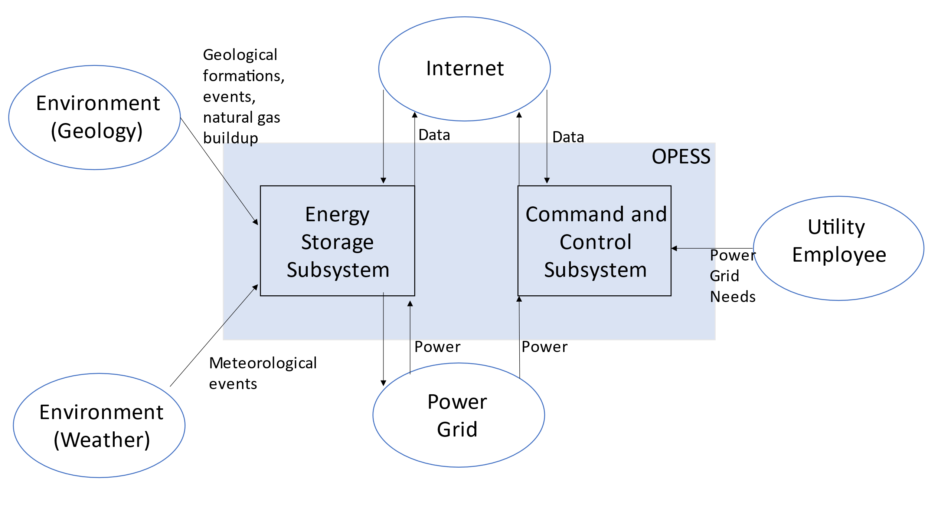

### 2.2.2 ESS Block Diagram

The ESS is the heart of the OPESS. It is composed of 5 functions, receive power, store power, generate power, a control node and weather protection. The primary function of the ESS is to act as a battery, hence the first three functions, however, unlike a batter, this is a complicated piece of equipment with lots of moving parts. A localized control note will have to be included in order to tell the individual components of the ESS how to behave. Additionally, this node will communicate with the CaCS and report and health and status issues the ESS might be experiencing.

Additionally, per risk 1, the ESS will be exposed to the elements on a regular bases and Oklahoma is famous for its bad weather. The final function, weather protection, is a risk reduction function meant to protect the ESS.

Figure :ESS Block Diagram End of TS Version

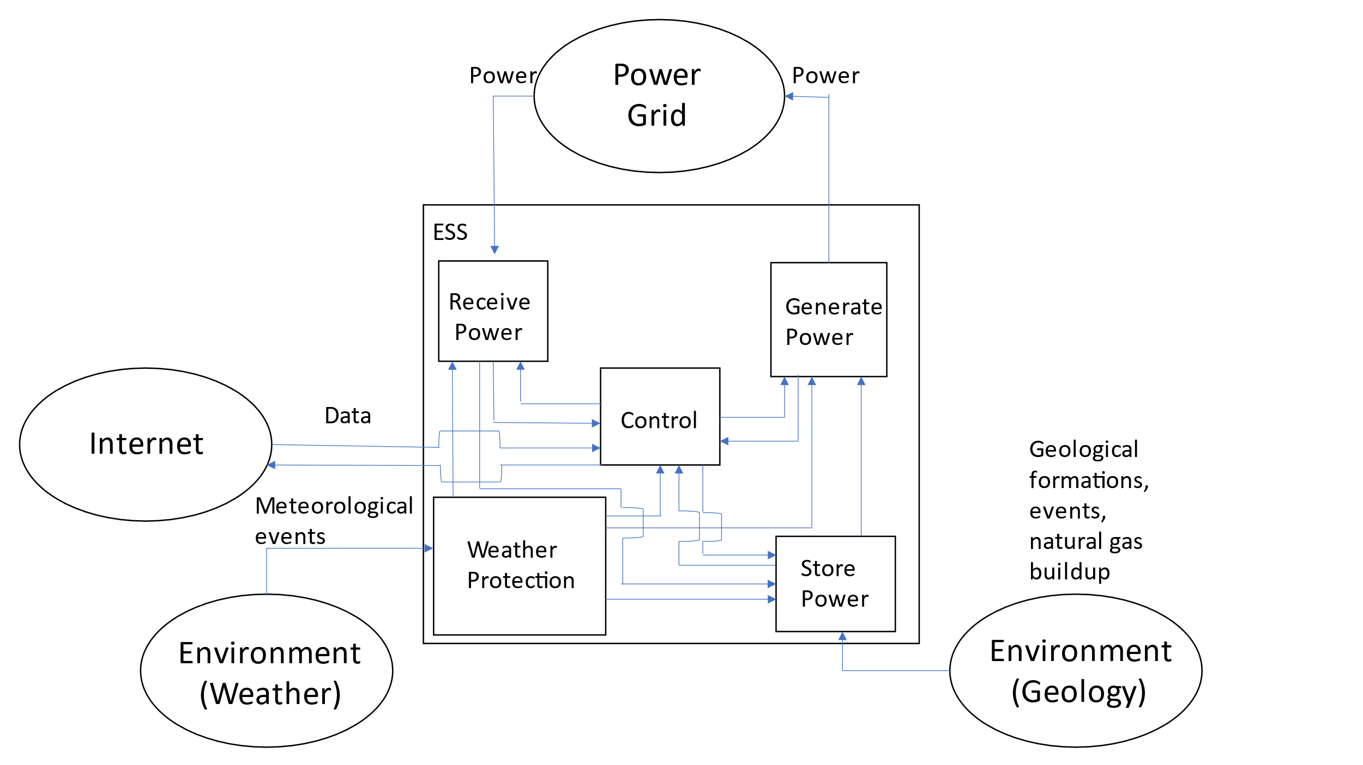

### 2.2.3 CaCS Block Diagram

The CaCS is the brains of the OPESS system. It exists primarily as an office space that allows utility workers, economists and engineers to communicate with other facilities both locally and across state lines in an effort to figure out what the future and current electrical needs will be. The CaCS will be able to allow employees access to modeling software in an effort of predict the future needs of the OPESS system on the grid. The CaCS will also allow employees to log into the ESS from their desk, monitor health and status and even control the ESS without having to go into the field. This will be helpful as issues can be diagnosed and handled without sending out technicians into the field.

Figure : CaCS Block Diagram End of TS Version

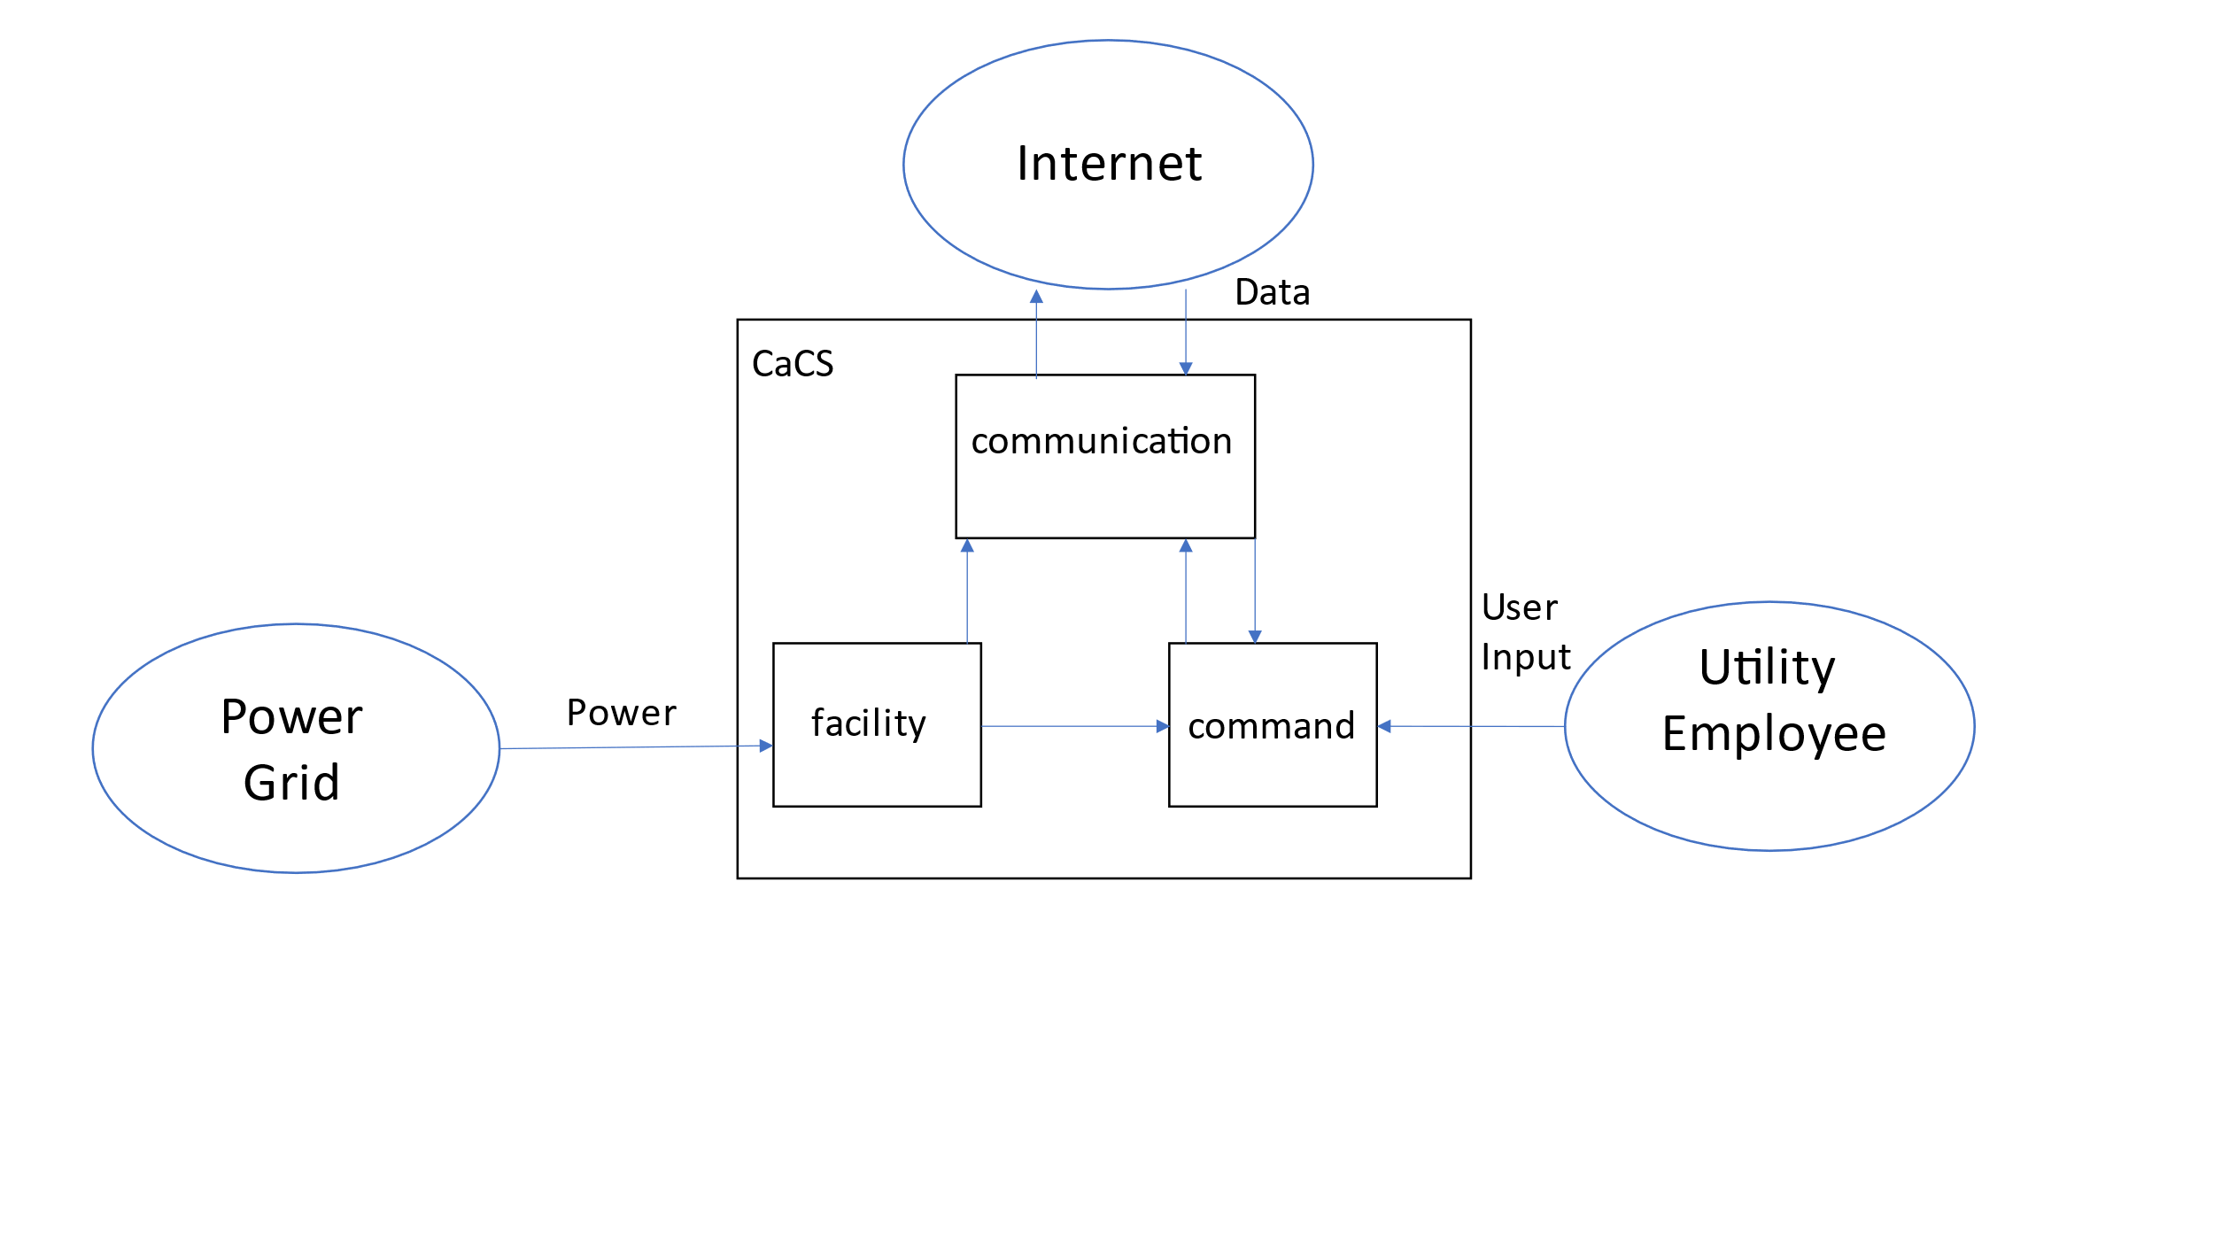

# 3 Trade Study

During the RAR, a cyber security expert was interviewed since anything involving the US power grid would be considered a piece of critical infrastructure. As a result, researching some form of cyber protection was decided to be a good choice for a trade study. Several of the requirements were analyzed and chooses to justify selection criteria. After looking at several of the products made available, another requirement was added to the OPESS since having that functionality was deemed a good idea.

# 3.1 Selection Criteria

URL filtering is defined as a program that lets the administrator determine what websites may or may not be blocked by a company. In addition, they may also come with a prepopulated list provided by the cyber security company based on their own research. This feature fulfills requirement 1.2.1.3.2 Cyber Filtering.

An Intrusion Prevention System is an aspect of a firewall that actively looks for suspicious behavior attempting to come across the network and blocks it. This feature fulfills requirement 1.2.1.3.6 CaCS IPS.

Transport Layer Security describes the type of encryption used at the transport layer of network security. This describes encryption schemes commonly used like https:// vs unencrypted schemes like http://. This feature fulfills requirement 1.2.1.3.7.

DDoS protection protects against a large network of computers pinging a single IP address in rapid succession and repeatedly until the server crashed. This feature fulfills requirement 1.2.1.3.8.

The antivirus offered by all the packages observed in the trade study offers to scan the all information and files that are housed on the cloud network for viruses and malware. This is extremely useful and this was included in the trade study but does not meet the requirement to provide an antivirus for all networked CaCS devices (see requirement 1.2.1.3.1 CaCs Anti-Virus) on its own. More antivirus software will need to be utilized to fully cover that requirement.

Cost was not included in this analysis. It was hoped early on that the weighted score of a package could be divided by its cost, giving us a utility per dollar value. However, all these packages charge a customer based on a negotiated deal. Since the OPESS is still in it’s early phases of development and the full size of the network is yet unknown, a final price tag was not available.

Table : Selection Criteria

|  | URL Filtering | Intrusion Prevention System (IPS) | Transport Layer Security (TLS) | Distributed Denial of Service | Antivirus | Geometric mean | Normalized weight |
| --- | --- | --- | --- | --- | --- | --- | --- |
| URL Filtering | 1.000 | 0.333 | 0.143 | 5.000 | 7.000 | 1.682 | 0.216 |
| Intrusion Prevention System (IPS) | 3.000 | 1.000 | 0.333 | 5.000 | 7.000 | 1.748 | 0.225 |
| Transport Layer Security (TLS) | 7.000 | 3.000 | 1.000 | 3.000 | 9.000 | 1.872 | 0.241 |
| Distributed Denial of Service | 0.200 | 0.200 | 0.333 | 1.000 | 3.000 | 1.365 | 0.175 |
| Antivirus | 0.143 | 0.143 | 0.111 | 0.333 | 1.000 | 1.116 | 0.143 |

# 3.2 Utility Curves

Since all the aspects of the security software were based on if they contained some capability or not, they really just allow for four level of utility.

No was given a designation of 0 since that functionality just was not offered by that particular platform.

Partial was given a score of 1 since some of the useful functionality was there but more can be offered by either an upgraded version of the software or by other platforms.

Add On was given a score of 2 since the full functionality was present on the platform but only if some additional cost was acceptable.

Yes, was given a score of 3 since this showed that the platform was capable of running the desired functionality

Figure : URL Filtering Utility Graph

Figure : Intrusion Prevention System Utility Graph

Figure : Transport Layer Security Utility Graph

Figure : Distributed Denial of Service Utility Graph

Figure : Antivirus Utility Graph

3.3 Trade Study

The five selection criteria were assigned the associated normalized weight to begin the trade study. Six different software packages were compared with two coming from Cloud Flare and four coming from Cisco Umbrella. The capabilities of each package were gathered from information made publicly available on their web site. Based on the status of an individual option, each criteria got assigned a value based on the utility it was assigned in section 3.2. This value was then multiplied by the weight factor for that criteria to create a weighted utility score. These scores were then added up to fine the total weighted utility value for that product.

Table : Trade Study

|  |  |  |  |  |  |  |  |  |  |  |  |  |  |  |  |  |  |  |  |  |
| --- | --- | --- | --- | --- | --- | --- | --- | --- | --- | --- | --- | --- | --- | --- | --- | --- | --- | --- | --- | --- |
| Criteria | Wei. | Cloud Flare Application Services | | | Cloud Flare Network Services | | | Cisco Umbrella DNS Security Essentials | | | Cisco Umbrella Security Advantage | | | Cisco Umbrella SIG Essentials | | | Cisco Umbrella SIG Advantage | | | |
| Option  Avail. | Util.  Score | Wei. Util. Score | Option  Avail. | Util.  Score | Wei. Util. Score | Option  Avail. | Util.  Score | Wei. Util. Score | Option  Avail. | Util.  Score | Wei. Util. Score | Option  Avail. | Util.  Score | Wei. Util. Score | Option  Avail. | Util.  Score | Wei. Util. Score |
| URL Filtering | 0.216 | No | 0 | 0.000 | Yes | 3 | 0.648 | Yes | 3 | 0.648 | Yes | 3 | 0.648 | Yes | 3 | 0.648 | Yes | 3 | 0.648 |
| Intrusion Prevention System (IPS) | 0.224 | Add On | 2 | 0.449 | No | 0 | 0.000 | Yes | 3 | 0.673 | Yes | 3 | 0.673 | Add on | 2 | 0.449 | Yes | 3 | 0.673 |
| Transport Layer Security (TLS) | 0.240 | YES | 3 | 0.721 | No | 0 | 0.000 | No | 0 | 0.000 | Partial | 1 | 0.240 | Yes | 3 | 0.721 | Yes | 3 | 0.721 |
| Distributed Denial of Service | 0.175 | Yes | 3 | 0.526 | Yes | 3 | 0.526 | No | 0 | 0.000 | No | 0 | 0.000 | No | 0 | 0.000 | No | 0 | 0.000 |
| Antivirus | 0.143 | Yes | 3 | 0.430 | No | 0 | 0.000 | No | 0 | 0.000 | No | 0 | 0.000 | Partial | 1 | 0.143 | Yes | 3 | 0.430 |
| Weighted Value | 2.126 | | | | 1.174 | | | 1.322 | | | 1.562 | | | 1.962 | | | 2.474 | | | |

The Cisco Umbrella SIG Advantage came out ahead in this trade study but was lacking in DDoS protections. Cloud Flare Application Services came in a close second and had DDoS protections but was missing URL filtering. As such, it is the advice of this trade study to include the Cisco Umbrella SIG Advantage package with an additional purchase of some form of DDoS protection.

# 3.4 Sensitivity Analysis

A sensitivity analysis was performed on the trade study. All in all, the Cisco Umbrella Application Service won out on all of them with the exception of zeroing out the URL filtering. This is because the URL filtering is one of the few methods that focuses on keeping you from going to risky websites and keeps helps keep you from being a target as opposed to mitigating data loss through encryption or early detection. Because of this, the URL Filtering was rated high. Zeroing it out had a rather large impact on the trade study.

Table : Trade Study Sensitivity Analysis

|  |  |
| --- | --- |
| Criteria | Trade Study winner |
| URL Filtering = 0 | Cloud Flare Application Services |
| Intrusion Prevention System (IPS) = 0 | Cisco Umbrella SIG Advantage |
| Transport Layer Security (TLS) = 0 | Cisco Umbrella SIG Advantage |
| Distributed Denial of Service = 0 | Cisco Umbrella SIG Advantage |
| Antivirus = 0 | Cisco Umbrella SIG Advantage |

# 4 Functional Changes

Due to changes from a local server network to a cloud-based architecture, 4 functions were deleted from the OPESS. These functions governed how data flowed to and from the servers and how a back up server integrated into the system. With the servers gone, there was no need for these functions. Their parent function was then updated to reflect the change to a cloud-based architecture.

In addition to that, one requirement was broken up into three so as to reduce its complexity and one new requirement was added as a result of this study. These new requirements needed to trace to a function. Fortunately, the functions already existed. AS a result, three functions now have additional requirements linked to them when compared to what was present in the FAR.

# 5 Requirement Analysis

## 5.1 Motivation for Requirement Update

As described in section 3, there was a change in architecture during the trade study. Several functions and requirements and functions were either removed for added as a result of the trade study. This updating of the requirements requires a further analysis. The effected requirements can be found in the table below. However, a full listing of requirements can be found in the attached VCRM.

Table : VCRM with new and updated requirements

| Num. | Name | Description | Refined By | Refines | KPP | Rationale | Title | Verification Method |
| --- | --- | --- | --- | --- | --- | --- | --- | --- |
| 1.1.1.5.4 | ESS URL Filtering | The ESS shall operate a firewall with URL filtering. |  | Requirement 1.1.1.5 ESS Internet Interface | FALSE | Derived from Interviews | Qualitative | VerificationRequirement Inspection |
| 1.1.1.5.10 | ESS IPS | The ESS shall operate a firewall with Intrusion Prevention System (IPS). |  | Requirement 1.1.1.5 ESS Internet Interface | FALSE | Derived from Interviews | Qualitative | VerificationRequirement Inspection |
| 1.1.1.5.11 | ESS TLS | The ESS shall operate a firewall with Transport Layer Security (TLS) inspection. |  | Requirement 1.1.1.5 ESS Internet Interface | FALSE | Derived from Interviews | Qualitative | VerificationRequirement Inspection |
| 1.1.1.5.12 | ESS DDoS Protection | The ESS shall communicate with the internet through a firewall with Intrusion Prevention System (IPS) and TLS inspection and URL filtering. |  | Requirement 1.1.1.5 ESS Internet Interface | FALSE | Derived from Requirements | Qualitative | VerificationRequirement Inspection |
| 1.2.1.3.2 | CaCS Cyber Filtering | The CaCS shall communicate with the internet through a firewall with URL filtering. |  | Requirement 1.2.1.3 CaCS Syber Security | FALSE | Derived from Interviews | Quantitative | VerificationRequirement Inspection |
| 1.2.1.3.3 | CaCS Firewall | The CaCS shall communicate with the internet through a firewall that uses different IPS signatures then the ESS firewall. |  | Requirement 1.2.1.3 CaCS Syber Security | FALSE | Derived from Interviews | Quantitative | VerificationRequirement Inspection |
| 1.2.1.3.4 | CaCS Intrusion Detection | The CaCS shall have an intrusion detection system. |  | Requirement 1.2.1.3 CaCS Syber Security | FALSE | Derived from Interviews | Quantitative | VerificationRequirement Inspection |
| 1.2.1.3.5 | CaCS TCP/IP | The CaCS shall communicate across a TCP/IP connection to the internet |  | Requirement 1.2.1.3 CaCS Syber Security | FALSE | Derived from Interviews | Quantitative | VerificationRequirement Inspection |
| 1.2.1.3.6 | CaCS IPS | The CaCS shall communicate with the internet through a firewall with Intrusion Prevention System (IPS). |  | Requirement 1.2.1.3 CaCS Syber Security | FALSE | Derived from Interviews | Qualitative | VerificationRequirement Inspection |
| 1.2.1.3.7 | CaCS TLS | The CaCS shall communicate with the internet through a firewall with Transport Layer Security (TLS). |  | Requirement 1.2.1.3 CaCS Syber Security | FALSE | Derived from Interviews | Qualitative | VerificationRequirement Inspection |
| 1.2.1.3.8 | CACS DDoS Protection | The CaCS shall communicate with the internet through a firewall with DDoS Protection. |  | Requirement 1.2.1.3 CaCS Syber Security | FALSE | Derived from Interviews | Qualitative | VerificationRequirement Inspection |

## 5.2 System Requirements

The requirements written for the OPESS system can be broken up into four different types:

Originating Requirements: The requirements stem from interviews from experts on various topics. They sometimes fill a performance or functional role in the OPESS system and can mostly be found labeled as both a originating and a performance/functional requirement.

Design Constraint: Design Constraints are choices that were made on the part of a requirement to achieve a goal. For example, “shall store energy” may be a functional phrase but “shall use a natural gas well” is a design choice on the part of the OPESS system.

Performance Requirements: Performance Requirements are any requirement that specifies some measure of performance of the OPESS system. These can be found as percentages, amounts or minimal standards as in the case of some software requirements.

Functional Requirements: Functional Requirements are requirements that provide or describe a function of the system. The phrase “shall store energy” describes a function of the OPESS system.

Table : Requirement Type

|  |  |
| --- | --- |
| Requirement Type | Number |
| Originating Requirements | 21 |
| Design Constraints | 21 |
| Performance Constraints | 40 |
| Functional Constraints | 69 |
| Total | 151 |

Additionally, since some of the Originating Requirements can double as both Functional or Performance most of them have actually been counted twice in the OPESS system with the exception of one. As such, that 151 number presented in Table 6 should actually read 131.

## 5.3 Requirement Verification

The requirements are verified through four verification methods.

Inspection: An inspection requirement is any requirement that can be verified via looking or some form of observation. Potential examples could be something like confirming a piece of software is coded per requirement or looking at a documented spec from a supplier.

Analysis: An analysis requirement is any requirement that requires multiple runs so that data can be built up. This data can then be analyzed to confirm that the behavior meets the requirement.

Demonstration: A demonstration requirement is any requirement that requires a demonstration of the functionality. An example might be like confirming that a pipe can hold up to 30 psi. Once the pipe is filled to that level, the requirement passes.

Test: A test requirement is any requirement that requires some form of formal test procedure. These can be related to demonstration requirements but typically require confirming consistent behavior of the system under multiple situations.

Table : Verification Method

|  |  |
| --- | --- |
| Verification Method | Number |
| Inspection | 43 |
| Analysis | 16 |
| Demonstration | 44 |
| Test | 28 |
| Total | 131 |

## 5.4 Key Performance Parameters

Key performance parameters (KPP’s) are requirements that were developed specifically to dictate key functions or standards important to the OPESS. These requirements form the backbone of the system.

Table : Key Performance Parameters

|  |  |
| --- | --- |
| Key Performance Parameters | Number |
| True | 12 |
| False | 119 |

Table : KPP Description

| KPP # | Req. # | Req. Name | Req. Description | Quantitative Vs. Qualitative | Verification Method |
| --- | --- | --- | --- | --- | --- |
| 1 | 1.1.1.5 | ESS Internet Interface | The ESS control node shall maintain a secure connection with the CaCS. | Qualitative | VerificationRequirement Test |
| 2 | 1.1.2.1.3 | ESS Generator Storage Interface | The ESS generator shall use compressed air coming from the natural gas well to spin a turbine and generate power. | Qualitative | VerificationRequirement Demonstration |
| 3 | 1.1.2.4.1 | ESS Carbon Capture Percent | The ESS carbon capture system shall remove no less than 50 percent of the hydrocarbons from the compressed air. | Quantitative | VerificationRequirement Test |
| 4 | 1.1.3.2.2 | ESS Storage Time | The ESS storage shall be able to keep compressed air for a period of up to 1 year. | Quantitative | VerificationRequirement Demonstration |
| 5 | 1.1.3.3.2 | ESS Storage Gas Safety Sensor | The ESS pressurized connection shall have an emergency release when the gas mixture reaches 4% according to the sensors. | Quantitative | VerificationRequirement Test |
| 6 | 1.1.3.3.4 | ESS Storage Leak | The ESS shall not allow the pressurized connection to leaked at a rate of more than 5% a year. | Quantitative | VerificationRequirement Test |
| 7 | 1.1.3.3.5 | ESS Storage Pressure | The ESS pressurized connection shall be able to handle up to 300 PSI. | Quantitative | VerificationRequirement Test |
| 8 | 1.1.4.1.1 | ESS Air Compressor | The ESS pump shall compress air and send it to the natural gas interface at pressure. | Qualitative | VerificationRequirement Demonstration |
| 9 | 1.1.5 | ESS Weather | The ESS shall be protected from the weather. | Qualitative | VerificationRequirement Test |
| 10 | 1.2.1.3 | CaCS Syber Security | The CaCS shall have a secure connection to the internet. | Qualitative | VerificationRequirement Test |
| 11 | 1.2.3 | CaCS Utility Interface | The CaCS shall receive data and commands from local utility employees. | Quantitative | VerificationRequirement Demonstration |
| 12 | 1.2.3.6 | CaCS Models | The CaCS shall provide software capable of creating and using utility models. | Qualitative | VerificationRequirement Demonstration |

## 5.5 Requirements Metric

The below table presents a list of all the metrics regarding the requirements derived for the FAR. This table will summarize the number of total requirements, KPP’s, qualitative vs quantitative and how each requirement will be verified.

Table : Requirements Metric

|  |  |  |  |  |  |  |  |  |
| --- | --- | --- | --- | --- | --- | --- | --- | --- |
| Report | Requirements | KPP’s | Qualitative | Quantitative | Inspection | Analysis | Demonstration | Test |
| RAR | 104 | 12 | 50 | 54 | 29 | 14 | 37 | 24 |
| FAR | 129 | 12 | 75 | 54 | 37 | 16 | 48 | 28 |
| TS | 131 | 12 | 79 | 52 | 43 | 16 | 44 | 28 |
| CDR |  |  |  |  |  |  |  |  |
| TP |  |  |  |  |  |  |  |  |
| A-Spec |  |  |  |  |  |  |  |  |
| Final |  |  |  |  |  |  |  |  |

# 6 Earned Value Management

## 6.1 Schedule

It was realized at the beginning of the trade study that the schedule had the CDR report immediately following the FAR. However, it was realized that it was actually the trade study that was expected next. Additionally, the risk report was also scheduled to be done before it really should have been. Because of this, the schedule has been updated to reflect the current expectations.

Figure : Schedule

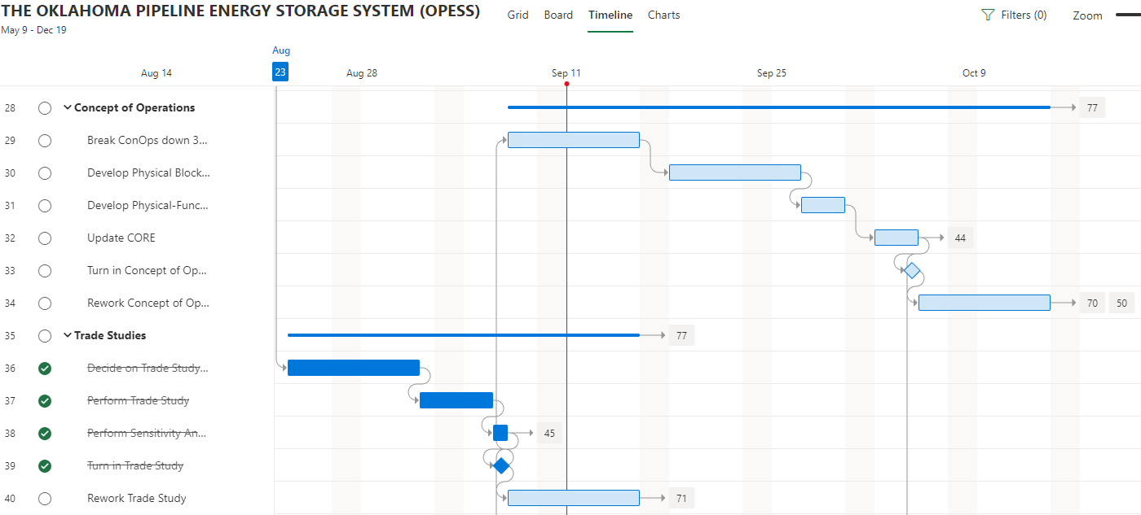

## 6.2 Milestones

Items in red were turned in late per the original due date. All other deliveries are expected to be on time.

Table : Milestones

| **Milestone** | **Date** |
| --- | --- |
| Project Proposal | 7/8/2022 |
| Requirements Report | 8/12/2022 |
| Functional Analysis | 9/2/2022 |
| Trade Study | 9/7/2022 |
| Concept of Operations | 10/5/2022 |
| Test Plan | 11/10/2022 |
| System Specifications | 11/28/2022 |
| Risk Management Report | 12/1/2022 |
| Final Report | 12/13/2022 |
| Oral Presentation | 12/14/2022 |

## 6.3 EVM

Table : EVM

|  |  |  |  |  |  |  |  |
| --- | --- | --- | --- | --- | --- | --- | --- |
| WBS number | Name | % Complete | Budget | BCWP | ACWP | SPI | CPI |
| **6** | **Trade Study** | **80.00%** |  |  |  |  |  |
| 6.1 | Decide on Trade Study Topic | 100.00% | 10 | 10.00 | 2 | 1 | 5.00 |
| 6.2 | Perform Trade Study | 100.00% | 3 | 3.00 | 3 | 1 | 1.00 |
| 6.3 | Perform Sensitivity Analysis | 100.00% | 1 | 1.00 | 0.5 | 1 | 2.00 |
| 6.4 | Turn in Trade Study | 100.00% | 0.5 | 0.50 | 5 | 1 | 0.10 |
| 6.5 | Rework Trade Study | 0.00% | 5 | 0.00 |  | 0 |  |

## 6.4 CPI and SPI Index

Figure : CPI and SPI Index

# 7 Risk

No new risks were discovered when performing the Trade Study. However, since the trade study delt exclusively with cyber security, which is risk 4, the over all risk to the OPESS was reduced.

## 7.1 Risk 1: Weather

Figure : Risk 1 Weather

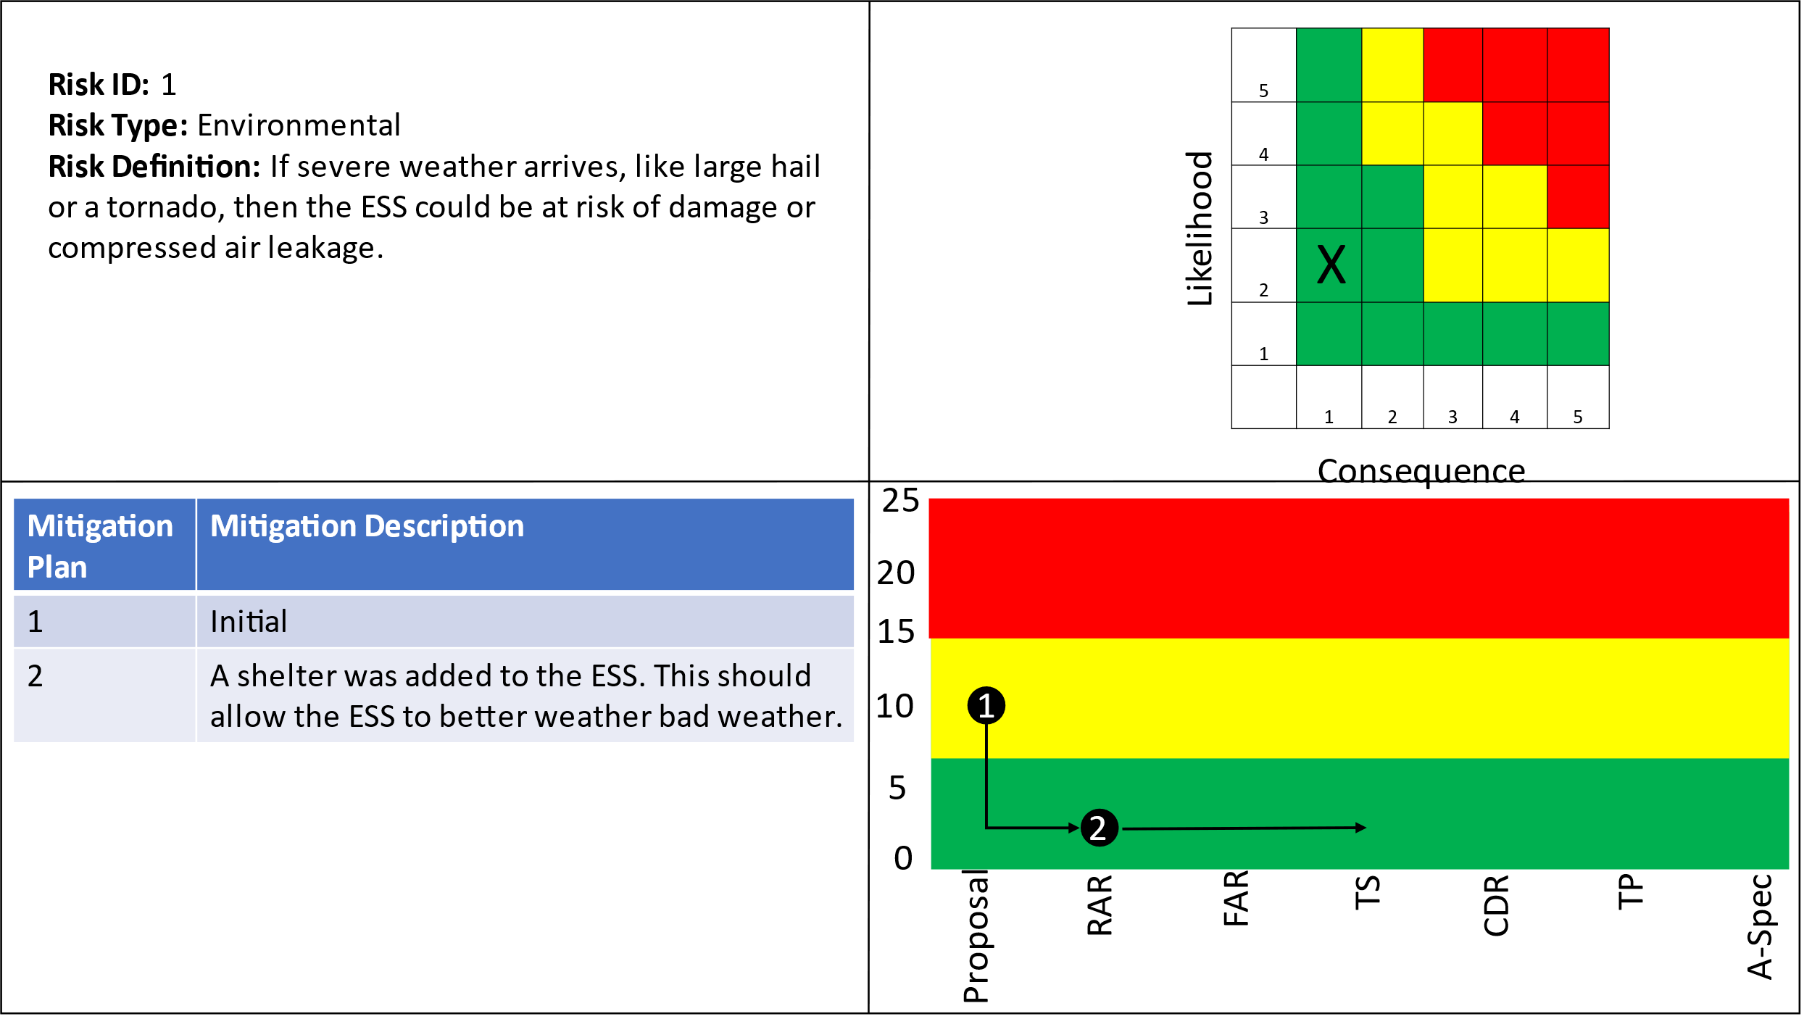

## 7.2 Risk 2: Earthquake

Figure : Risk 2 Earthquake

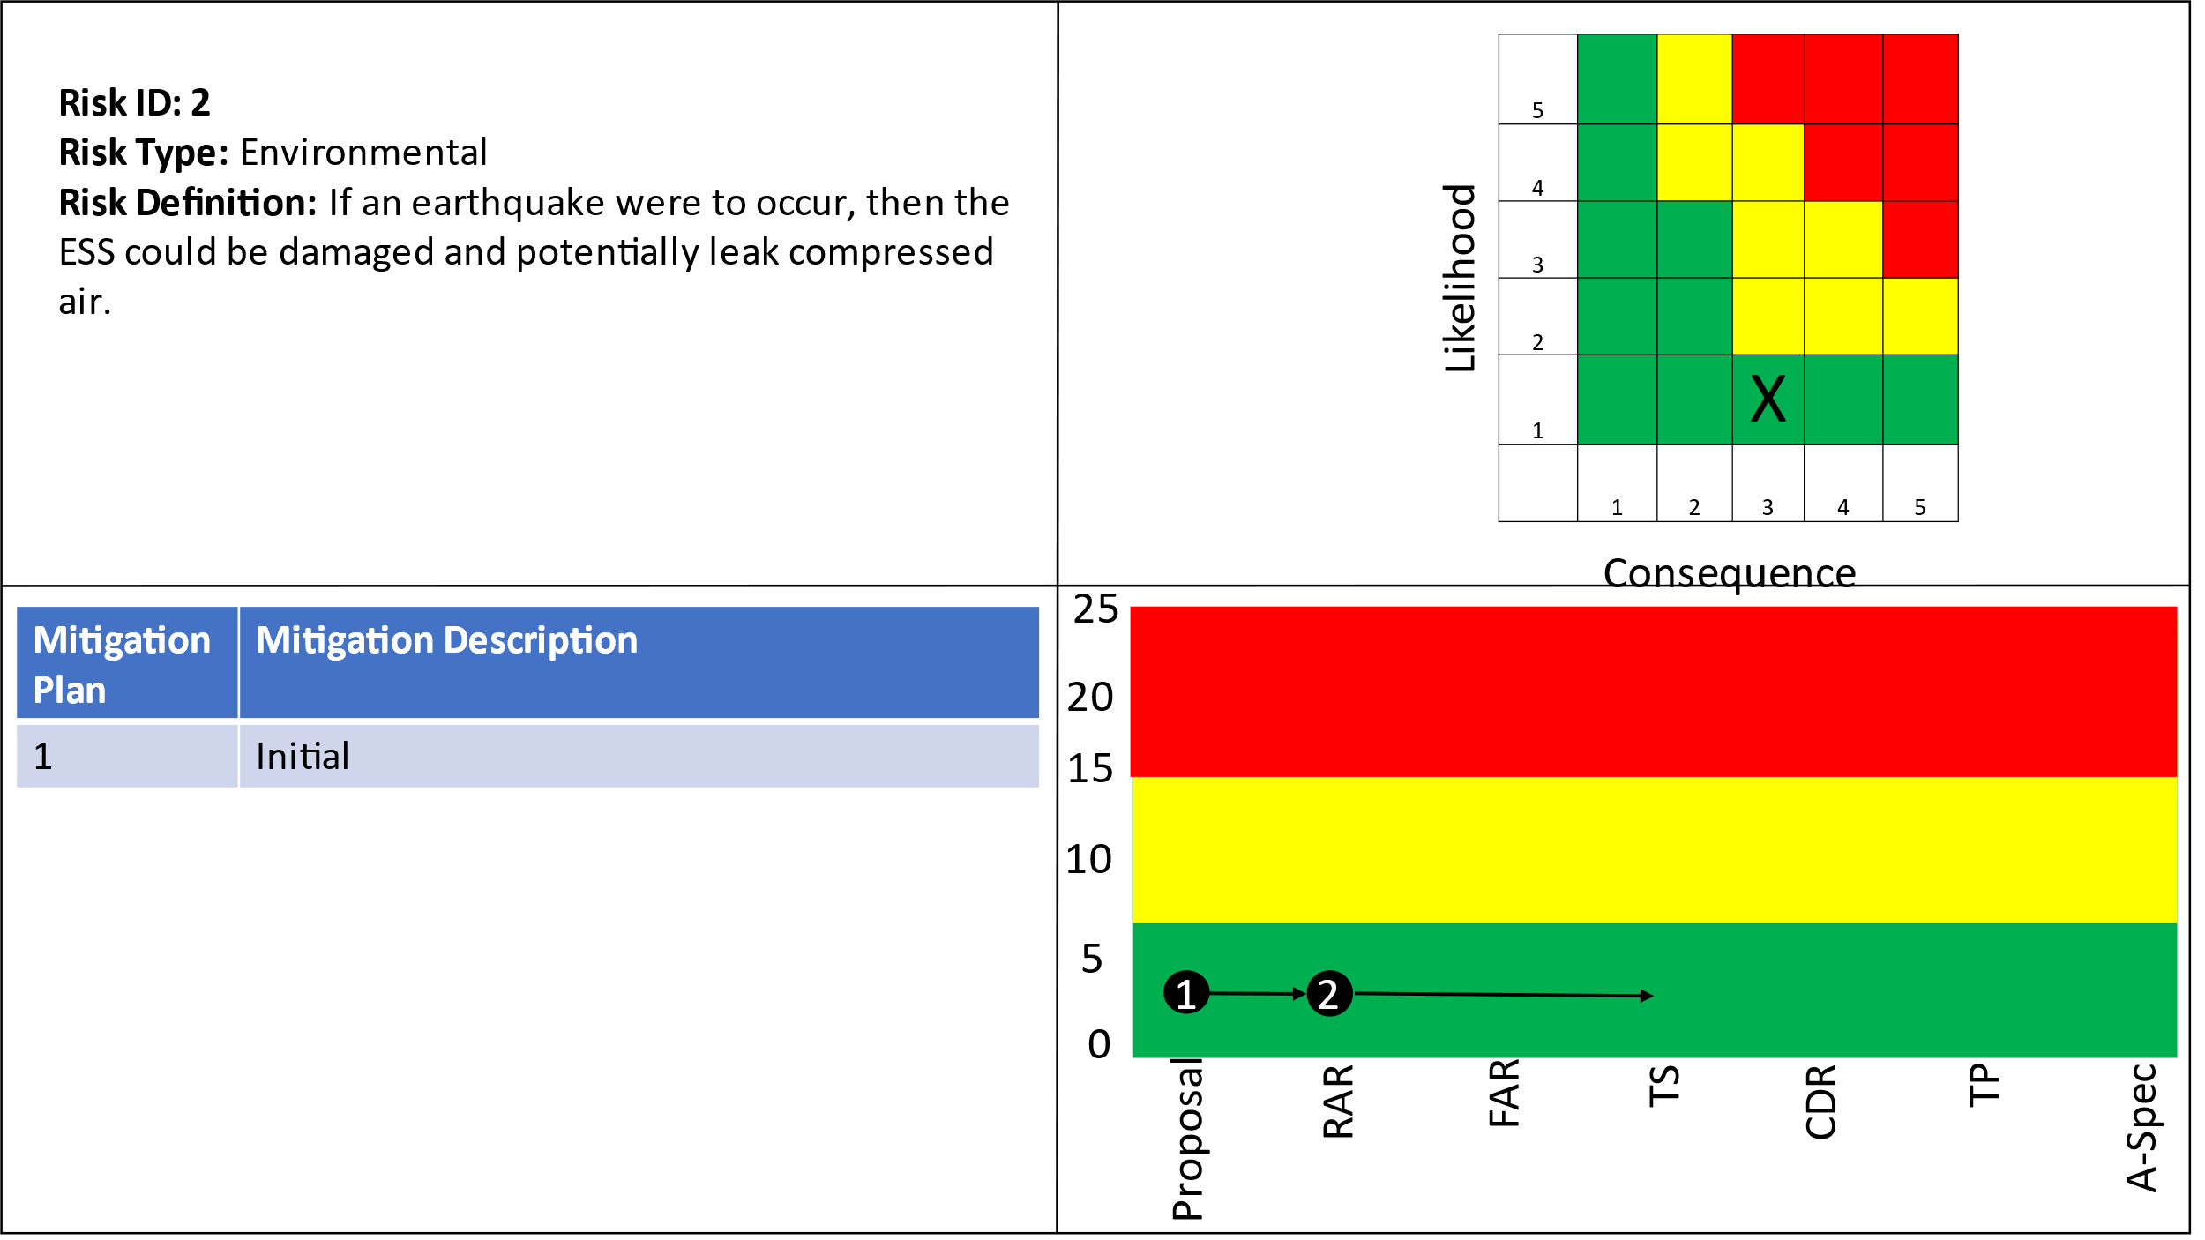

## 7.3 Risk 3: Residual Natural Gas

Figure : Risk 3 Residual Natural Gas

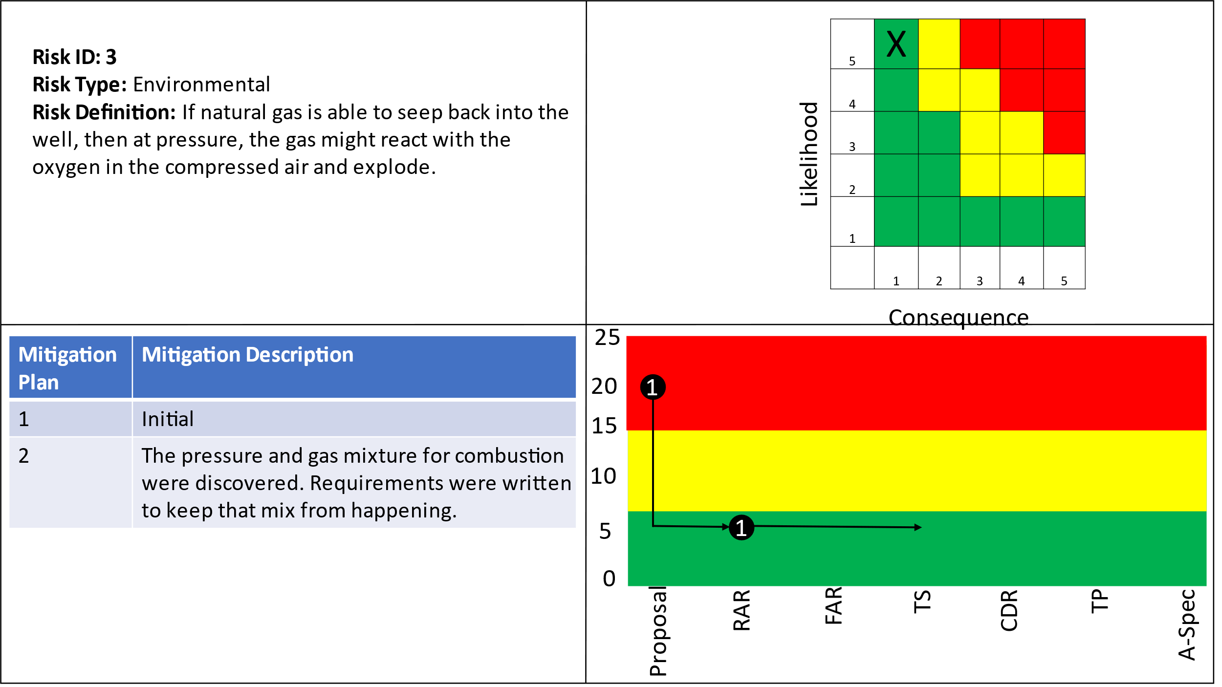

## 7.4 Risk 4: Cyber Security

Figure : Risk 4 Cyber Security

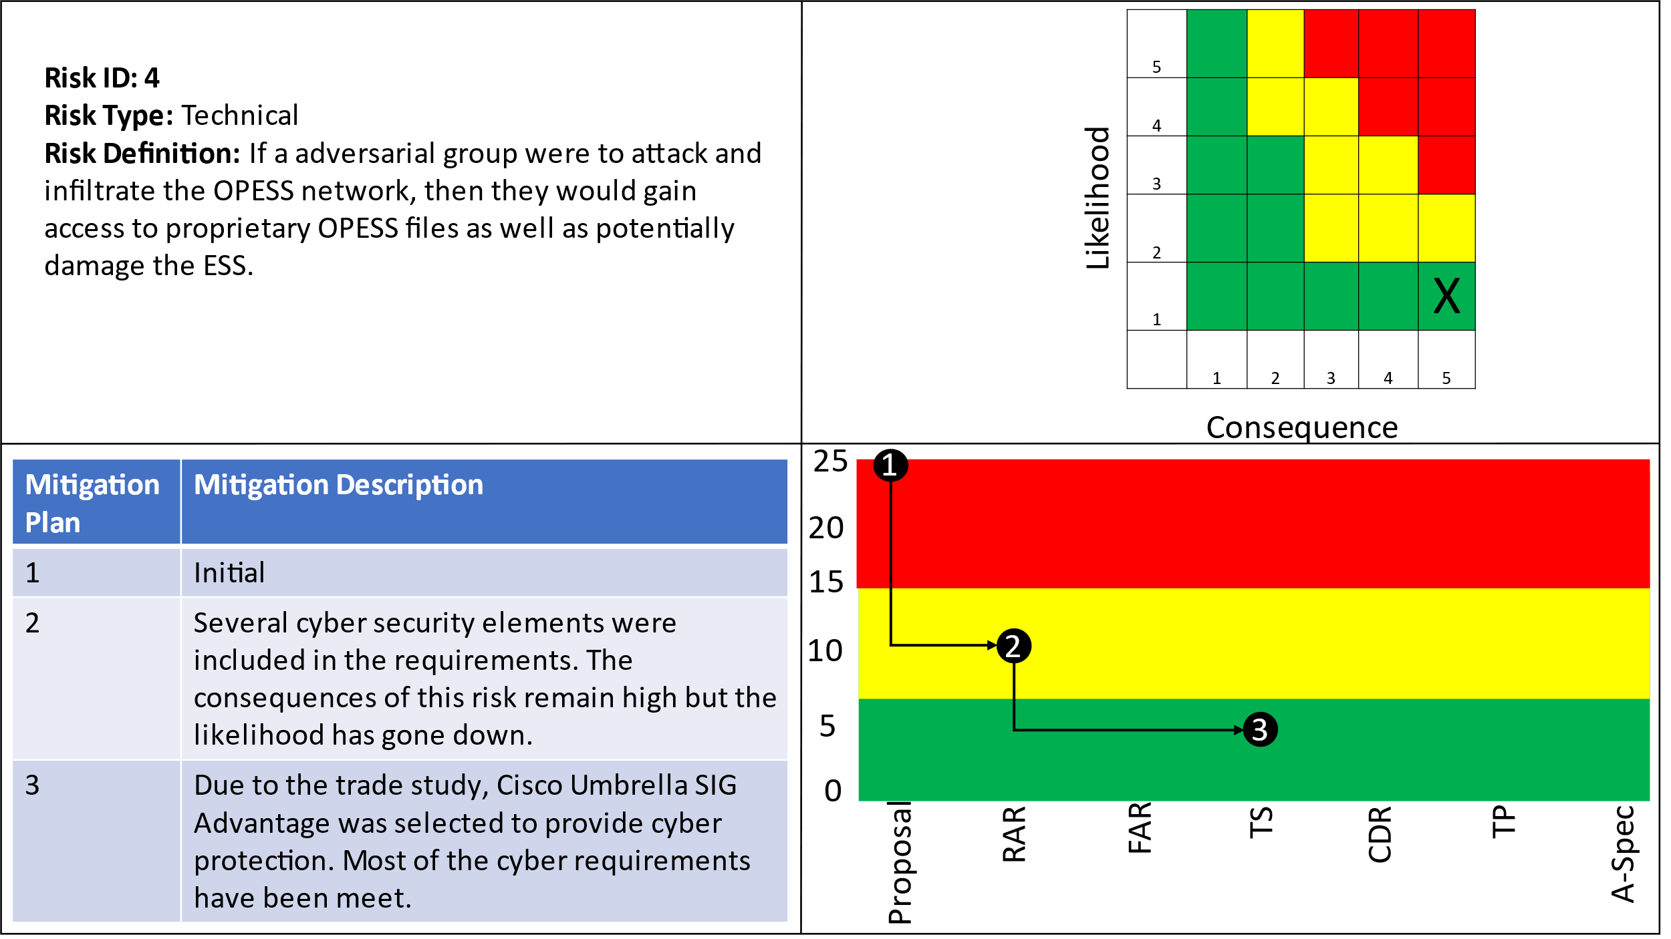

# 8 References

Cisco Umbrella Packages. (2022). *Cisco Umbrella*. Retrieved from Cisco: https://umbrella.cisco.com/products/umbrella-enterprise-security-packages

Cloud Flare. (2022). *Application Services*. Retrieved from Cloud Flare : https://www.cloudflare.com/plans/application-services/#overview

*Electricity explained: How electricity is delivered to consumers.* (2022, August 11). Retrieved from US Energy Information Administration: https://www.eia.gov/energyexplained/electricity/delivery-to-consumers.php

Grubelich, M. C., Bauer, S. J., & Cooper, P. W. (2011, September). *Potential Hazards of Compressed Air Energy Storage in Depleted Natural Gas Reservoirs.* Retrieved from Sandia Report: https://www.osti.gov/servlets/purl/1029814/

Popovich, N., & Plumer, B. (2020, 10 28). *How Does Your State Make Electricity?* Retrieved from The New York Times: https://www.nytimes.com/interactive/2020/10/28/climate/how-electricity-generation-changed-in-your-state-election.html

*The Basics of Underground Natural Gas Storage* . (2015, 11 16). Retrieved from US Energy Information Administration: https://www.eia.gov/naturalgas/storage/basics/

U.S. Energy Information Administration. (2022, May 19). *Oklahoma State Profile and Energy Estimates*. Retrieved from U.S. Energy Information Administration: https://www.eia.gov/state/analysis.php?sid=OK

# Appendix A: Sensitivity Analysis

Table : Sensitivity Analysis 1

|  |  |  |  |  |  |  |  |  |  |  |  |  |  |  |  |  |  |  |  |
| --- | --- | --- | --- | --- | --- | --- | --- | --- | --- | --- | --- | --- | --- | --- | --- | --- | --- | --- | --- |
| Criteria | Wei. | Cloud Flare Application Services | | | Cloud Flare Network Services | | | Cisco Umbrella DNS Security Essentials | | | Cisco Umbrella Security Advantage | | | Cisco Umbrella SIG Essentials | | | Cisco Umbrella SIG Advantage | | |
| Option  Avail. | Util.  Score | Wei. Util. Score | Option  Avail. | Util.  Score | Wei. Util. Score | Option Available | Utility Score | Option  Avail. | Util.  Score | Wei. Util. Score | Option  Avail. | Util.  Score | Wei. Util. Score | Weighted Utility Score | Option Available | Option  Avail. | Util.  Score |
| URL Filtering | 0.000 | No | 0.000 | 0.000 | Yes | 3.000 | 0.000 | Yes | 3.000 | 0.000 | Yes | 3.000 | 0.000 | Yes | 3.000 | 0.000 | Yes | 3.000 | 0.000 |
| Intrusion Prevention System (IPS) | 0.225 | Add On | 2.000 | 0.449 | No | 0.000 | 0.000 | Yes | 3.000 | 0.674 | Yes | 3.000 | 0.674 | Add on | 2.000 | 0.449 | Yes | 3.000 | 0.674 |
| Transport Layer Security (TLS) | 0.241 | YES | 3.000 | 0.722 | No | 0.000 | 0.000 | No | 0.000 | 0.000 | Partial | 1.000 | 0.241 | Yes | 3.000 | 0.722 | Yes | 3.000 | 0.722 |
| Distributed Denial of Service | 0.175 | Yes | 3.000 | 0.526 | Yes | 3.000 | 0.526 | No | 0.000 | 0.000 | No | 0.000 | 0.000 | No | 0.000 | 0.000 | No | 0.000 | 0.000 |
| Antivirus | 0.143 | Yes | 3.000 | 0.430 | No | 0.000 | 0.000 | No | 0.000 | 0.000 | No | 0.000 | 0.000 | Partial | 1.000 | 0.143 | Yes | 3.000 | 0.430 |
| Weighted Value |  |  |  | 2.127 |  |  | 0.526 |  |  | 0.674 |  |  | 0.914 |  |  | 1.314 |  |  | 1.826 |

Table : Sensitivity Analysis 2

|  |  |  |  |  |  |  |  |  |  |  |  |  |  |  |  |  |  |  |  |
| --- | --- | --- | --- | --- | --- | --- | --- | --- | --- | --- | --- | --- | --- | --- | --- | --- | --- | --- | --- |
| Criteria | Wei. | Cloud Flare Application Services | | | Cloud Flare Network Services | | | Cisco Umbrella DNS Security Essentials | | | Cisco Umbrella Security Advantage | | | Cisco Umbrella SIG Essentials | | | Cisco Umbrella SIG Advantage | | |
| Option  Avail. | Util.  Score | Wei. Util. Score | Option  Avail. | Util.  Score | Wei. Util. Score | Option Available | Utility Score | Option  Avail. | Util.  Score | Wei. Util. Score | Option  Avail. | Util.  Score | Wei. Util. Score | Weighted Utility Score | Option Available | Option  Avail. | Util.  Score |
| URL Filtering | 0.216 | No | 0.000 | 0.000 | Yes | 3.000 | 0.648 | Yes | 3.000 | 0.648 | Yes | 3.000 | 0.648 | Yes | 3.000 | 0.648 | Yes | 3.000 | 0.648 |
| Intrusion Prevention System (IPS) | 0.000 | Add On | 2.000 | 0.000 | No | 0.000 | 0.000 | Yes | 3.000 | 0.000 | Yes | 3.000 | 0.000 | Add on | 2.000 | 0.000 | Yes | 3.000 | 0.000 |
| Transport Layer Security (TLS) | 0.241 | YES | 3.000 | 0.722 | No | 0.000 | 0.000 | No | 0.000 | 0.000 | Partial | 1.000 | 0.241 | Yes | 3.000 | 0.722 | Yes | 3.000 | 0.722 |
| Distributed Denial of Service | 0.175 | Yes | 3.000 | 0.526 | Yes | 3.000 | 0.526 | No | 0.000 | 0.000 | No | 0.000 | 0.000 | No | 0.000 | 0.000 | No | 0.000 | 0.000 |
| Antivirus | 0.143 | Yes | 3.000 | 0.430 | No | 0.000 | 0.000 | No | 0.000 | 0.000 | No | 0.000 | 0.000 | Partial | 1.000 | 0.143 | Yes | 3.000 | 0.430 |
| Weighted Value |  |  |  | 1.678 |  |  | 1.174 |  |  | 0.648 |  |  | 0.889 |  |  | 1.513 |  |  | 1.800 |

Table : Sensitivity Analysis 3

|  |  |  |  |  |  |  |  |  |  |  |  |  |  |  |  |  |  |  |  |
| --- | --- | --- | --- | --- | --- | --- | --- | --- | --- | --- | --- | --- | --- | --- | --- | --- | --- | --- | --- |
| Criteria | Wei. | Cloud Flare Application Services | | | Cloud Flare Network Services | | | Cisco Umbrella DNS Security Essentials | | | Cisco Umbrella Security Advantage | | | Cisco Umbrella SIG Essentials | | | Cisco Umbrella SIG Advantage | | |
| Option  Avail. | Util.  Score | Wei. Util. Score | Option  Avail. | Util.  Score | Wei. Util. Score | Option Available | Utility Score | Option  Avail. | Util.  Score | Wei. Util. Score | Option  Avail. | Util.  Score | Wei. Util. Score | Weighted Utility Score | Option Available | Option  Avail. | Util.  Score |
| URL Filtering | 0.216 | No | 0.000 | 0.000 | Yes | 3.000 | 0.648 | Yes | 3.000 | 0.648 | Yes | 3.000 | 0.648 | Yes | 3.000 | 0.648 | Yes | 3.000 | 0.648 |
| Intrusion Prevention System (IPS) | 0.225 | Add On | 2.000 | 0.449 | No | 0.000 | 0.000 | Yes | 3.000 | 0.674 | Yes | 3.000 | 0.674 | Add on | 2.000 | 0.449 | Yes | 3.000 | 0.674 |
| Transport Layer Security (TLS) | 0.000 | YES | 3.000 | 0.000 | No | 0.000 | 0.000 | No | 0.000 | 0.000 | Partial | 1.000 | 0.000 | Yes | 3.000 | 0.000 | Yes | 3.000 | 0.000 |
| Distributed Denial of Service | 0.175 | Yes | 3.000 | 0.526 | Yes | 3.000 | 0.526 | No | 0.000 | 0.000 | No | 0.000 | 0.000 | No | 0.000 | 0.000 | No | 0.000 | 0.000 |
| Antivirus | 0.143 | Yes | 3.000 | 0.430 | No | 0.000 | 0.000 | No | 0.000 | 0.000 | No | 0.000 | 0.000 | Partial | 1.000 | 0.143 | Yes | 3.000 | 0.430 |
| Weighted Value |  |  |  | 1.405 |  |  | 1.174 |  |  | 1.322 |  |  | 1.322 |  |  | 1.241 |  |  | 1.752 |

Table : Sensitivity Analysis 4

|  |  |  |  |  |  |  |  |  |  |  |  |  |  |  |  |  |  |  |  |
| --- | --- | --- | --- | --- | --- | --- | --- | --- | --- | --- | --- | --- | --- | --- | --- | --- | --- | --- | --- |
| Criteria | Wei. | Cloud Flare Application Services | | | Cloud Flare Network Services | | | Cisco Umbrella DNS Security Essentials | | | Cisco Umbrella Security Advantage | | | Cisco Umbrella SIG Essentials | | | Cisco Umbrella SIG Advantage | | |
| Option  Avail. | Util.  Score | Wei. Util. Score | Option  Avail. | Util.  Score | Wei. Util. Score | Option Available | Utility Score | Option  Avail. | Util.  Score | Wei. Util. Score | Option  Avail. | Util.  Score | Wei. Util. Score | Weighted Utility Score | Option Available | Option  Avail. | Util.  Score |
| URL Filtering | 0.216 | No | 0.000 | 0.000 | Yes | 3.000 | 0.648 | Yes | 3.000 | 0.648 | Yes | 3.000 | 0.648 | Yes | 3.000 | 0.648 | Yes | 3.000 | 0.648 |
| Intrusion Prevention System (IPS) | 0.225 | Add On | 2.000 | 0.449 | No | 0.000 | 0.000 | Yes | 3.000 | 0.674 | Yes | 3.000 | 0.674 | Add on | 2.000 | 0.449 | Yes | 3.000 | 0.674 |
| Transport Layer Security (TLS) | 0.241 | YES | 3.000 | 0.722 | No | 0.000 | 0.000 | No | 0.000 | 0.000 | Partial | 1.000 | 0.241 | Yes | 3.000 | 0.722 | Yes | 3.000 | 0.722 |
| Distributed Denial of Service | 0.000 | Yes | 3.000 | 0.000 | Yes | 3.000 | 0.000 | No | 0.000 | 0.000 | No | 0.000 | 0.000 | No | 0.000 | 0.000 | No | 0.000 | 0.000 |
| Antivirus | 0.143 | Yes | 3.000 | 0.430 | No | 0.000 | 0.000 | No | 0.000 | 0.000 | No | 0.000 | 0.000 | Partial | 1.000 | 0.143 | Yes | 3.000 | 0.430 |
| Weighted Value |  |  |  | 1.601 |  |  | 0.648 |  |  | 1.322 |  |  | 1.563 |  |  | 1.963 |  |  | 2.474 |

Table : Sensitivity Analysis 5

|  |  |  |  |  |  |  |  |  |  |  |  |  |  |  |  |  |  |  |  |
| --- | --- | --- | --- | --- | --- | --- | --- | --- | --- | --- | --- | --- | --- | --- | --- | --- | --- | --- | --- |
| Criteria | Wei. | Cloud Flare Application Services | | | Cloud Flare Network Services | | | Cisco Umbrella DNS Security Essentials | | | Cisco Umbrella Security Advantage | | | Cisco Umbrella SIG Essentials | | | Cisco Umbrella SIG Advantage | | |
| Option  Avail. | Util.  Score | Wei. Util. Score | Option  Avail. | Util.  Score | Wei. Util. Score | Option Available | Utility Score | Option  Avail. | Util.  Score | Wei. Util. Score | Option  Avail. | Util.  Score | Wei. Util. Score | Weighted Utility Score | Option Available | Option  Avail. | Util.  Score |
| URL Filtering | 0.216 | No | 0.000 | 0.000 | Yes | 3.000 | 0.648 | Yes | 3.000 | 0.648 | Yes | 3.000 | 0.648 | Yes | 3.000 | 0.648 | Yes | 3.000 | 0.648 |
| Intrusion Prevention System (IPS) | 0.225 | Add On | 2.000 | 0.449 | No | 0.000 | 0.000 | Yes | 3.000 | 0.674 | Yes | 3.000 | 0.674 | Add on | 2.000 | 0.449 | Yes | 3.000 | 0.674 |
| Transport Layer Security (TLS) | 0.241 | YES | 3.000 | 0.722 | No | 0.000 | 0.000 | No | 0.000 | 0.000 | Partial | 1.000 | 0.241 | Yes | 3.000 | 0.722 | Yes | 3.000 | 0.722 |
| Distributed Denial of Service | 0.175 | Yes | 3.000 | 0.526 | Yes | 3.000 | 0.526 | No | 0.000 | 0.000 | No | 0.000 | 0.000 | No | 0.000 | 0.000 | No | 0.000 | 0.000 |
| Antivirus | 0.000 | Yes | 3.000 | 0.000 | No | 0.000 | 0.000 | No | 0.000 | 0.000 | No | 0.000 | 0.000 | Partial | 1.000 | 0.000 | Yes | 3.000 | 0.000 |
| Weighted Value |  |  |  | 1.697 |  |  | 1.174 |  |  | 1.322 |  |  | 1.563 |  |  | 1.819 |  |  | 2.044 |

# Appendix B: Verification Cross Reference Matrix

Table : VCRM

| Num. | Name | Description | Refined By | Refines | KPP | Rationale | Title | Verification Method |
| --- | --- | --- | --- | --- | --- | --- | --- | --- |
| 1 | OPESS Requirements | The Oklahoma Pipeline Energy Storage System (OPESS) shall operate as an energy storage system on the electrical grid. | Requirement 1.1 ESS Requirement Requirement 1.2 CaCS Requirements |  | FALSE | Design decision | Qualitative | VerificationRequirement Analysis |
| 1.1 | ESS Requirement | The Energy Storage Subsystem (ESS) shall actively store and generate energy for use on the electrical grid. | Requirement 1.1.1 ESS Communications Requirement 1.1.2 ESS Generate Power Requirement 1.1.3 ESS Power Storage Requirement 1.1.4 ESS Receive Power Requirement 1.1.5 ESS Weather | Requirement 1 OPESS Requirements | FALSE | Design decision | Qualitative | VerificationRequirement Demonstration |
| 1.1.1 | ESS Communications | The ESS shall send and receive information and commands from the CaCS via the internet. | Requirement 1.1.1.1 ESS Control Requirement 1.1.1.2 ESS Control Node Process Commands Requirement 1.1.1.3 ESS Control Node Receive Commands Requirement 1.1.1.4 ESS Control Node Send Commands Requirement 1.1.1.5 ESS Internet Interface Requirement 1.1.1.6 ESS Send Health and Status | Requirement 1.1 ESS Requirement | FALSE | Design decision | Quantitative | VerificationRequirement Demonstration |
| 1.1.1.1 | ESS Control | The ESS control node shall process commands from the CaCS. | Requirement 1.1.1.1.1 ESS Health and Status Send Requirement 1.1.1.1.2 ESS Processor Communication Requirement 1.1.1.1.3 ESS Processor Health and Status Receive Requirement 1.1.1.1.4 ESS Processor Response Requirement 1.1.1.1.5 ESS Command Process Requirement 1.1.1.1.6 ESS to Component Connection Requirement 1.1.1.1.7 ESS Component Processor Communication Requirement 1.1.1.1.8 ESS Component Communication | Requirement 1.1.1 ESS Communications | FALSE | Design decision | Quantitative | VerificationRequirement Test |
| 1.1.1.1.1 | ESS Health and Status Send | The ESS processor shall scan the health and status updates and send them to the CaCS. |  | Requirement 1.1.1.1 ESS Control | FALSE | Design decision | Qualitative | VerificationRequirement Demonstration |
| 1.1.1.1.2 | ESS Processor Communication | The ESS processor shall receive commands from the CaCS. |  | Requirement 1.1.1.1 ESS Control | FALSE | Design decision | Quantitative | VerificationRequirement Demonstration |
| 1.1.1.1.3 | ESS Processor Health and Status Receive | The ESS processor shall receive health and Status from the components. |  | Requirement 1.1.1.1 ESS Control | FALSE | Design decision | Quantitative | VerificationRequirement Demonstration |
| 1.1.1.1.4 | ESS Processor Response | The ESS processor shall automatically respond to any health or safety issue its receives. |  | Requirement 1.1.1.1 ESS Control | FALSE | Design decision | Qualitative | VerificationRequirement Test |
| 1.1.1.1.5 | ESS Command Process | The ESS shall process commands and responses coming from the ESS. |  | Requirement 1.1.1.1 ESS Control | FALSE | Design decision | Qualitative | VerificationRequirement Test |
| 1.1.1.1.6 | ESS to Component Connection | The ESS shall connect the ESS components to the internet through a processor |  | Requirement 1.1.1.1 ESS Control | FALSE | Design decision | Qualitative | VerificationRequirement Demonstration |
| 1.1.1.1.7 | ESS Component Processor Communication | The ESS shall monitor health and status and report that information to the CaCS. |  | Requirement 1.1.1.1 ESS Control | FALSE | Design decision | Qualitative | VerificationRequirement Inspection |
| 1.1.1.1.8 | ESS Component Communication | The ESS shall allow the ESS components to communicate with the ESS processor. |  | Requirement 1.1.1.1 ESS Control | FALSE | Design decision | Qualitative | VerificationRequirement Demonstration |
| 1.1.1.2 | ESS Control Node Process Commands | The ESS control node shall process input from the generator, storage and compressor apparatus. |  | Requirement 1.1.1 ESS Communications | FALSE | Design decision | Qualitative | VerificationRequirement Analysis |
| 1.1.1.3 | ESS Control Node Receive Commands | The ESS control node shall receive information from the generator, storage and compressor apparatus. |  | Requirement 1.1.1 ESS Communications | FALSE | Design decision | Quantitative | VerificationRequirement Demonstration |
| 1.1.1.4 | ESS Control Node Send Commands | The ESS control node shall send CaCS commands to the generator, storage apparatus and the compressor. |  | Requirement 1.1.1 ESS Communications | FALSE | Design decision | Quantitative | VerificationRequirement Demonstration |
| 1.1.1.5 | ESS Internet Interface | The ESS control node shall maintain a secure connection with the CaCS. | Requirement 1.1.1.5.1 ESS Cyber Scans Requirement 1.1.1.5.2 ESS Encryption Requirement 1.1.1.5.3 ESS Fiber Optics Requirement 1.1.1.5.4 ESS URL Filtering Requirement 1.1.1.5.5 ESS High Speed Internet Requirement 1.1.1.5.6 ESS TCP/IP Requirement 1.1.1.5.7 ESS Internet Connection Requirement 1.1.1.5.8 ESS Cyber Security Suite Requirement 1.1.1.5.9 ESS Secure Connection Requirement 1.1.1.5.10 ESS IPS Requirement 1.1.1.5.11 ESS TLS Requirement 1.1.1.5.12 ESS DDoS Protection | Requirement 1.1.1 ESS Communications | TRUE | Design decision | Qualitative | VerificationRequirement Test |
| 1.1.1.5.1 | ESS Cyber Scans | The ESS shall undergo security scans at least once a quarter. |  | Requirement 1.1.1.5 ESS Internet Interface | FALSE | Derived from Interviews | Quantitative | VerificationRequirement Inspection |
| 1.1.1.5.2 | ESS Encryption | The ESS connection to the CaCS shall be encrypted with a AES-256 connection or stronger |  | Requirement 1.1.1.5 ESS Internet Interface | FALSE | Derived from Interviews | Qualitative | VerificationRequirement Inspection |
| 1.1.1.5.3 | ESS Fiber Optics | The ESS shall use either a IEEE802.3 Ethernet or Fiber Optic connection. |  | Requirement 1.1.1.5 ESS Internet Interface | FALSE | Derived from Interviews | Qualitative | VerificationRequirement Inspection |
| 1.1.1.5.4 | ESS URL Filtering | The ESS shall operate a firewall with URL filtering. |  | Requirement 1.1.1.5 ESS Internet Interface | FALSE | Derived from Interviews | Qualitative | VerificationRequirement Inspection |
| 1.1.1.5.5 | ESS High Speed Internet | The ESS shall maintain a high-speed connection to the internet. |  | Requirement 1.1.1.5 ESS Internet Interface | FALSE | Design decision | Quantitative | VerificationRequirement Analysis |
| 1.1.1.5.6 | ESS TCP/IP | The ESS shall use a TCP/IP connection. |  | Requirement 1.1.1.5 ESS Internet Interface | FALSE | Derived from Interviews | Qualitative | VerificationRequirement Inspection |
| 1.1.1.5.7 | ESS Internet Connection | The ESS network shall connect to the Internet. |  | Requirement 1.1.1.5 ESS Internet Interface | FALSE | Design decision | Qualitative | VerificationRequirement Demonstration |
| 1.1.1.5.8 | ESS Cyber Security Suite | The ESS internet connection shall function with a cyber security suite. |  | Requirement 1.1.1.5 ESS Internet Interface | FALSE | Design decision | Qualitative | VerificationRequirement Inspection |
| 1.1.1.5.9 | ESS Secure Connection | The ESS shall connect to the Internet through a secure connection. |  | Requirement 1.1.1.5 ESS Internet Interface | FALSE | Design decision | Qualitative | VerificationRequirement Analysis |
| 1.1.1.5.10 | ESS IPS | The ESS shall operate a firewall with Intrusion Prevention System (IPS). |  | Requirement 1.1.1.5 ESS Internet Interface | FALSE | Derived from Interviews | Qualitative | VerificationRequirement Inspection |
| 1.1.1.5.11 | ESS TLS | The ESS shall operate a firewall with Transport Layer Security (TLS) inspection. |  | Requirement 1.1.1.5 ESS Internet Interface | FALSE | Derived from Interviews | Qualitative | VerificationRequirement Inspection |
| 1.1.1.5.12 | ESS DDoS Protection | The ESS shall communicate with the internet through a firewall with Intrusion Prevention System (IPS) and TLS inspection and URL filtering. |  | Requirement 1.1.1.5 ESS Internet Interface | FALSE | Derived from Requirements | Qualitative | VerificationRequirement Inspection |
| 1.1.1.6 | ESS Send Health and Status | The ESS control node shall send the input from the generator, storage and compressor apparatus to the CaCS. |  | Requirement 1.1.1 ESS Communications | FALSE | Design decision | Quantitative | VerificationRequirement Demonstration |
| 1.1.2 | ESS Generate Power | The ESS shall generate power from storage for use on the power grid. | Requirement 1.1.2.1 ESS Generator Requirement 1.1.2.2 ESS Power Uptake Requirement 1.1.2.3 ESS Storage Generator Interface Requirement 1.1.2.4 ESS Carbon Capture | Requirement 1.1 ESS Requirement | FALSE | Design decision | Qualitative | VerificationRequirement Demonstration |
| 1.1.2.1 | ESS Generator | The ESS shall use compressed air to run a generator. | Requirement 1.1.2.1.1 ESS Generator Commands Requirement 1.1.2.1.2 ESS Generator Health and Status Requirement 1.1.2.1.3 ESS Generator Storage Interface Requirement 1.1.2.1.4 ESS Generator Utility Interface | Requirement 1.1.2 ESS Generate Power | FALSE | Design decision | Qualitative | VerificationRequirement Demonstration |
| 1.1.2.1.1 | ESS Generator Commands | The ESS generator shall receive commands from the CaCS telling it to turn on, off and how hard to run. |  | Requirement 1.1.2.1 ESS Generator | FALSE | Design decision | Quantitative | VerificationRequirement Test |
| 1.1.2.1.2 | ESS Generator Health and Status | The ESS generator shall send health and safety information to the processor as well as receive any emergency commands. |  | Requirement 1.1.2.1 ESS Generator | FALSE | Design decision | Quantitative | VerificationRequirement Test |
| 1.1.2.1.3 | ESS Generator Storage Interface | The ESS generator shall use compressed air coming from the natural gas well to spin a turbine and generate power. |  | Requirement 1.1.2.1 ESS Generator | TRUE | Design decision | Qualitative | VerificationRequirement Demonstration |
| 1.1.2.1.4 | ESS Generator Utility Interface | The ESS shall send its power to the Utility Connection. |  | Requirement 1.1.2.1 ESS Generator | FALSE | Design decision | Qualitative | VerificationRequirement Demonstration |
| 1.1.2.2 | ESS Power Uptake | The ESS shall send electrical power onto the utility grid via a utility interface | Requirement 1.1.2.2.1 ESS Generator Grid interface Requirement 1.1.2.2.2 ESS Generator Transformer | Requirement 1.1.2 ESS Generate Power | FALSE | Design decision | Qualitative | VerificationRequirement Inspection |
| 1.1.2.2.1 | ESS Generator Grid interface | The ESS shall send power from the step-up generator to the electrical grid |  | Requirement 1.1.2.2 ESS Power Uptake | FALSE | Design decision | Qualitative | VerificationRequirement Inspection |
| 1.1.2.2.2 | ESS Generator Transformer | The ESS shall send power from the generator to a step-up transformer. |  | Requirement 1.1.2.2 ESS Power Uptake | FALSE | Derived from Research | Qualitative | VerificationRequirement Inspection |
| 1.1.2.3 | ESS Storage Generator Interface | The ESS shall pull compressed air from the storage device through a pressurized interface. | Requirement 1.1.2.3.1 ESS Power Generation Requirement 1.1.2.3.2 Generator Health and Status Requirement 1.1.2.3.3 Power Generation Gauge Requirement 1.1.2.3.4 Compressed Air Power Generation Requirement 1.1.2.3.5 Generation to Grid Connection Requirement 1.1.2.3.6 ESS Generator to Grid Requirement 1.1.2.3.7 Generator Step Up | Requirement 1.1.2 ESS Generate Power | FALSE | Design decision | Qualitative | VerificationRequirement Demonstration |
| 1.1.2.3.1 | ESS Power Generation | The ESS shall generate power. |  | Requirement 1.1.2.3 ESS Storage Generator Interface | FALSE | Design decision | Qualitative | VerificationRequirement Demonstration |
| 1.1.2.3.2 | Generator Health and Status | The ESS shall monitor the ESS generator health and status. |  | Requirement 1.1.2.3 ESS Storage Generator Interface | FALSE | Design decision | Qualitative | VerificationRequirement Inspection |
| 1.1.2.3.3 | Power Generation Gauge | The ESS shall control the amount of power generated by the generator. |  | Requirement 1.1.2.3 ESS Storage Generator Interface | FALSE | Design decision | Qualitative | VerificationRequirement Test |
| 1.1.2.3.4 | Compressed Air Power Generation | The ESS shall generate power from compressed air as needed. |  | Requirement 1.1.2.3 ESS Storage Generator Interface | FALSE | Design decision | Qualitative | VerificationRequirement Test |
| 1.1.2.3.5 | Generation to Grid Connection | The ESS generator shall connect to the electrical grid. |  | Requirement 1.1.2.3 ESS Storage Generator Interface | FALSE | Design decision | Qualitative | VerificationRequirement Demonstration |
| 1.1.2.3.6 | ESS Generator to Grid | The ESS shall connect the power grid to the generator. |  | Requirement 1.1.2.3 ESS Storage Generator Interface | FALSE | Design decision | Qualitative | VerificationRequirement Inspection |
| 1.1.2.3.7 | Generator Step Up | The ESS shall step up the power generated for use on the electric grid. |  | Requirement 1.1.2.3 ESS Storage Generator Interface | FALSE | Design decision | Qualitative | VerificationRequirement Analysis |
| 1.1.2.4 | ESS Carbon Capture | The ESS shall send all the compressed air used by the generator through a carbon capture system. | Requirement 1.1.2.4.1 ESS Carbon Capture Percent Requirement 1.1.2.4.2 ESS Carbon Capture Release | Requirement 1.1.2 ESS Generate Power | FALSE | Design decision | Qualitative | VerificationRequirement Inspection |
| 1.1.2.4.1 | ESS Carbon Capture Percent | The ESS carbon capture system shall remove no less than 50 percent of the hydrocarbons from the compressed air. |  | Requirement 1.1.2.4 ESS Carbon Capture | TRUE | Design decision | Quantitative | VerificationRequirement Test |
| 1.1.2.4.2 | ESS Carbon Capture Release | Once passed through the carbon capture system, the ESS shall release all the compressed air used by the generator into the environment. |  | Requirement 1.1.2.4 ESS Carbon Capture | FALSE | Design decision | Quantitative | VerificationRequirement Inspection |
| 1.1.3 | ESS Power Storage | The ESS shall store power in natural gas wells. | Requirement 1.1.3.1 ESS Compressed air monitoring Requirement 1.1.3.2 ESS Compressed air storage Requirement 1.1.3.3 ESS Pressure | Requirement 1.1 ESS Requirement | FALSE | Design decision | Qualitative | VerificationRequirement Inspection |
| 1.1.3.1 | ESS Compressed air monitoring | The ESS storage shall monitor gas in the natural gas well. | Requirement 1.1.3.1.1 ESS Gas Monitoring Requirement 1.1.3.1.2 ESS Storage pressure monitoring Requirement 1.1.3.1.3 ESS Storage Sensors Requirement 1.1.3.1.4 ESS SW Max Gas mix Requirement 1.1.3.1.5 ESS SW Max PSI Requirement 1.1.3.1.6 Chemical Monitoring Requirement 1.1.3.1.7 Pressure Monitoring | Requirement 1.1.3 ESS Power Storage | FALSE | Design decision | Qualitative | VerificationRequirement Test |
| 1.1.3.1.1 | ESS Gas Monitoring | The ESS sensors shall monitor the gas makeup throughout the well and send that information to the CaCS. |  | Requirement 1.1.3.1 ESS Compressed air monitoring | FALSE | Design decision | Quantitative | VerificationRequirement Test |
| 1.1.3.1.2 | ESS Storage pressure monitoring | The ESS sensors shall monitor pressure throughout the well and send that information to the CaCS. |  | Requirement 1.1.3.1 ESS Compressed air monitoring | FALSE | Design decision | Quantitative | VerificationRequirement Test |
| 1.1.3.1.3 | ESS Storage Sensors | The ESS shall imbed sensors in the natural gas well. |  | Requirement 1.1.3.1 ESS Compressed air monitoring | FALSE | Design decision | Quantitative | VerificationRequirement Inspection |
| 1.1.3.1.4 | ESS SW Max Gas mix | The ESS sensors shall send a fault to the CaCS when the natural gas makeup reaches 3%. |  | Requirement 1.1.3.1 ESS Compressed air monitoring | FALSE | Derived from Research | Quantitative | VerificationRequirement Test |
| 1.1.3.1.5 | ESS SW Max PSI | The ESS sensors shall send a fault to the CaCS telling them the well is full at 200 PSI. |  | Requirement 1.1.3.1 ESS Compressed air monitoring | FALSE | Derived from Research | Quantitative | VerificationRequirement Test |
| 1.1.3.1.6 | Chemical Monitoring | The ESS shall monitor the gas makeup in the natural gas wells. |  | Requirement 1.1.3.1 ESS Compressed air monitoring | FALSE | Design decision | Qualitative | VerificationRequirement Inspection |
| 1.1.3.1.7 | Pressure Monitoring | The ESS shall monitor the pressure in the natural gas wells. |  | Requirement 1.1.3.1 ESS Compressed air monitoring | FALSE | Design decision | Qualitative | VerificationRequirement Inspection |
| 1.1.3.2 | ESS Compressed air storage | The ESS storage shall keep compressed air in natural gas wells. | Requirement 1.1.3.2.1 ESS Gas Safety Requirement 1.1.3.2.2 ESS Storage Time Requirement 1.1.3.2.3 ESS Well Initialization Requirement 1.1.3.2.4 ESS Well Initialization Gas Release | Requirement 1.1.3 ESS Power Storage | FALSE | Design decision | Qualitative | VerificationRequirement Analysis |
| 1.1.3.2.1 | ESS Gas Safety | Upon initialization, the ESS natural gas well shall be filled with nitrogen gas such that residual natural gas makes up 2% or less. |  | Requirement 1.1.3.2 ESS Compressed air storage | FALSE | Derived from Research | Quantitative | VerificationRequirement Analysis |
| 1.1.3.2.2 | ESS Storage Time | The ESS storage shall be able to keep compressed air for a period of up to 1 year. |  | Requirement 1.1.3.2 ESS Compressed air storage | TRUE | Design decision | Quantitative | VerificationRequirement Demonstration |
| 1.1.3.2.3 | ESS Well Initialization | The ESS shall use only depleted natural gas wells. |  | Requirement 1.1.3.2 ESS Compressed air storage | FALSE | Design decision | Qualitative | VerificationRequirement Analysis |
| 1.1.3.2.4 | ESS Well Initialization Gas Release | Once the well is full of nitrogen, the ESS shall release the gas mixture and repeat the process until the residual natural gas makes up less than .5% of the gas mixture at atmospheric pressure. |  | Requirement 1.1.3.2 ESS Compressed air storage | FALSE | Derived from Research | Quantitative | VerificationRequirement Test |
| 1.1.3.3 | ESS Pressure | The ESS storage shall be able to handle compressed air at pressure. | Requirement 1.1.3.3.1 ESS Emergency Pressure Release Requirement 1.1.3.3.2 ESS Storage Gas Safety Sensor Requirement 1.1.3.3.3 ESS Storage Generator Requirement Requirement 1.1.3.3.4 ESS Storage Leak Requirement 1.1.3.3.5 ESS Storage Pressure Requirement 1.1.3.3.6 ESS Storage Pump Interface Requirement 1.1.3.3.7 Constant Pressure Requirement 1.1.3.3.8 ESS Emergency Release | Requirement 1.1.3 ESS Power Storage | FALSE | Design decision | Qualitative | VerificationRequirement Demonstration |
| 1.1.3.3.1 | ESS Emergency Pressure Release | The ESS pressurized connection shall have an emergency pressure release that automatically trips at 250 PSI. |  | Requirement 1.1.3.3 ESS Pressure | FALSE | Derived from Research | Quantitative | VerificationRequirement Test |
| 1.1.3.3.2 | ESS Storage Gas Safety Sensor | The ESS pressurized connection shall have an emergency release when the gas mixture reaches 4% according to the sensors. |  | Requirement 1.1.3.3 ESS Pressure | TRUE | Derived from Research | Quantitative | VerificationRequirement Test |
| 1.1.3.3.3 | ESS Storage Generator Requirement | The ESS shall be able to send air to the generator at pressure. |  | Requirement 1.1.3.3 ESS Pressure | FALSE | Design decision | Qualitative | VerificationRequirement Demonstration |
| 1.1.3.3.4 | ESS Storage Leak | The ESS shall not allow the pressurized connection to leaked at a rate of more than 5% a year. |  | Requirement 1.1.3.3 ESS Pressure | TRUE | Design decision | Quantitative | VerificationRequirement Test |
| 1.1.3.3.5 | ESS Storage Pressure | The ESS pressurized connection shall be able to handle up to 300 PSI. |  | Requirement 1.1.3.3 ESS Pressure | TRUE | Derived from Research | Quantitative | VerificationRequirement Test |
| 1.1.3.3.6 | ESS Storage Pump Interface | The ESS shall be able to receive air from the compressor at pressure. |  | Requirement 1.1.3.3 ESS Pressure | FALSE | Design decision | Qualitative | VerificationRequirement Demonstration |
| 1.1.3.3.7 | Constant Pressure | The ESS shall maintain and hold a constant pressure when either the generator or pump are not in use |  | Requirement 1.1.3.3 ESS Pressure | FALSE | Design decision | Qualitative | VerificationRequirement Demonstration |
| 1.1.3.3.8 | ESS Emergency Release | The ESS shall have an emergency pressure release. |  | Requirement 1.1.3.3 ESS Pressure | FALSE | Design decision | Qualitative | VerificationRequirement Inspection |
| 1.1.4 | ESS Receive Power | The ESS shall receive power off the power grid and send it to storage. | Requirement 1.1.4.1 ESS Air Pump Requirement 1.1.4.2 ESS Power Intake Requirement 1.1.4.3 ESS Pump Storage Interface | Requirement 1.1 ESS Requirement | FALSE | Design decision | Qualitative | VerificationRequirement Demonstration |
| 1.1.4.1 | ESS Air Pump | The ESS shall use a pump to compress air. | Requirement 1.1.4.1.1 ESS Air Compressor Requirement 1.1.4.1.2 ESS Command Requirement 1.1.4.1.3 ESS Health and Status Requirement 1.1.4.1.4 ESS Health and Status communication Requirement 1.1.4.1.5 ESS Transformer Connection Requirement 1.1.4.1.6 ESS Compressed Air Requirement 1.1.4.1.7 Compressed Air Transport | Requirement 1.1.4 ESS Receive Power | FALSE | Design decision | Qualitative | VerificationRequirement Demonstration |
| 1.1.4.1.1 | ESS Air Compressor | The ESS pump shall compress air and send it to the natural gas interface at pressure. |  | Requirement 1.1.4.1 ESS Air Pump | TRUE | Design decision | Qualitative | VerificationRequirement Demonstration |
| 1.1.4.1.2 | ESS Command | The ESS pump shall receive its commands from the from the ESS control. |  | Requirement 1.1.4.1 ESS Air Pump | FALSE | Design decision | Quantitative | VerificationRequirement Test |
| 1.1.4.1.3 | ESS Health and Status | The ESS shall report Its health and status to the CaCS. |  | Requirement 1.1.4.1 ESS Air Pump | FALSE | Design decision | Quantitative | VerificationRequirement Demonstration |
| 1.1.4.1.4 | ESS Health and Status communication | The ESS shall send the ESS control it's health and status. |  | Requirement 1.1.4.1 ESS Air Pump | FALSE | Design decision | Quantitative | VerificationRequirement Inspection |
| 1.1.4.1.5 | ESS Transformer Connection | The ESS shall connect to the step-down transformer for power |  | Requirement 1.1.4.1 ESS Air Pump | FALSE | Derived from Research | Qualitative | VerificationRequirement Inspection |
| 1.1.4.1.6 | ESS Compressed Air | The ESS shall compress compressed air. |  | Requirement 1.1.4.1 ESS Air Pump | FALSE | Design decision | Qualitative | VerificationRequirement Demonstration |
| 1.1.4.1.7 | Compressed Air Transport | The ESS shall send compressed air to a natural gas well. |  | Requirement 1.1.4.1 ESS Air Pump | FALSE | Design decision | Qualitative | VerificationRequirement Demonstration |
| 1.1.4.2 | ESS Power Intake | The ESS shall receive power off the grid by way of a utility interface. | Requirement 1.1.4.2.1 ESS Power Connection Requirement 1.1.4.2.2 ESS Transformer Requirement 1.1.4.2.3 ESS Voltage Adjust | Requirement 1.1.4 ESS Receive Power | FALSE | Design decision | Qualitative | VerificationRequirement Inspection |
| 1.1.4.2.1 | ESS Power Connection | The ESS shall have a hardwired connection to the high voltage lines of the power grid |  | Requirement 1.1.4.2 ESS Power Intake | FALSE | Derived from Research | Qualitative | VerificationRequirement Inspection |
| 1.1.4.2.2 | ESS Transformer | The ESS shall have a step-down transformer to lower the voltage to US Standard 120V 60Hz. |  | Requirement 1.1.4.2 ESS Power Intake | FALSE | Design decision | Quantitative | VerificationRequirement Inspection |
| 1.1.4.2.3 | ESS Voltage Adjust | The ESS shall adjust the voltage coming from the utility lines to a lower voltage. |  | Requirement 1.1.4.2 ESS Power Intake | FALSE | Design decision | Qualitative | VerificationRequirement Demonstration |
| 1.1.4.3 | ESS Pump Storage Interface | The ESS shall send the compressed air from the pump to the storage device through a pressurized interface. |  | Requirement 1.1.4 ESS Receive Power | FALSE | Design decision | Qualitative | VerificationRequirement Demonstration |
| 1.1.5 | ESS Weather | The ESS shall be protected from the weather. | Requirement 1.1.5.1 ESS Cooling Requirement 1.1.5.2 ESS Hail Requirement 1.1.5.3 ESS Heating Requirement 1.1.5.4 ESS Tornado Requirement 1.1.5.5 ESS Wind Requirement 1.1.5.6 Weather Protect Requirement 1.1.5.7 Climate Control | Requirement 1.1 ESS Requirement | TRUE | Design decision | Qualitative | VerificationRequirement Test |
| 1.1.5.1 | ESS Cooling | The ESS shall be able to maintain a working temperature of 100 degrees Fahrenheit or below |  | Requirement 1.1.5 ESS Weather | FALSE | Design decision | Quantitative | VerificationRequirement Test |
| 1.1.5.2 | ESS Hail | The ESS shall be able to withstand up to baseball size hail. |  | Requirement 1.1.5 ESS Weather | FALSE | Design decision | Quantitative | VerificationRequirement Test |
| 1.1.5.3 | ESS Heating | The ESS shall be able to maintain a working temperature of 40 degrees Fahrenheit or above. |  | Requirement 1.1.5 ESS Weather | FALSE | Design decision | Quantitative | VerificationRequirement Test |
| 1.1.5.4 | ESS Tornado | The ESS shall be able to withstand a EF4 tornado. |  | Requirement 1.1.5 ESS Weather | FALSE | Design decision | Quantitative | VerificationRequirement Analysis |
| 1.1.5.5 | ESS Wind | The ESS shall be able to withstand up to 60 mph strait line winds. |  | Requirement 1.1.5 ESS Weather | FALSE | Design decision | Quantitative | VerificationRequirement Test |
| 1.1.5.6 | Weather Protect | The ESS shall be protected from outside weather. |  | Requirement 1.1.5 ESS Weather | FALSE | Design decision | Qualitative | VerificationRequirement Test |
| 1.1.5.7 | Climate Control | The ESS shall implement climate control. |  | Requirement 1.1.5 ESS Weather | FALSE | Design decision | Qualitative | VerificationRequirement Demonstration |
| 1.2 | CaCS Requirements | The Command-and-Control Subsystem (CaCS) shall act as the operational command center of the OPESS. | Requirement 1.2.1 CaCS Communications Requirement 1.2.2 CaCS Receive Power Requirement 1.2.3 CaCS Utility Interface | Requirement 1 OPESS Requirements | FALSE | Design decision | Qualitative | VerificationRequirement Analysis |
| 1.2.1 | CaCS Communications | The CaCS shall communicate with the ESS and other utilities via the internet. | Requirement 1.2.1.1 CaCS Internal Network Requirement 1.2.1.2 CaCS Servers Requirement 1.2.1.3 CaCS Syber Security | Requirement 1.2 CaCS Requirements | FALSE | Design decision | Qualitative | VerificationRequirement Demonstration |
| 1.2.1.1 | CaCS Internal Network | The CaCS shall maintain an active internal network. | Requirement 1.2.1.1.1 CaCS High Speed Network Requirement 1.2.1.1.2 CaCS Log In Requirement 1.2.1.1.3 CaCS Ring Network Requirement 1.2.1.1.4 CaCS Security Scan Requirement 1.2.1.1.5 CaCS VM | Requirement 1.2.1 CaCS Communications | FALSE | Design decision | Qualitative | VerificationRequirement Demonstration |
| 1.2.1.1.1 | CaCS High Speed Network | The CaCS shall use a high-speed network. |  | Requirement 1.2.1.1 CaCS Internal Network | FALSE | Design decision | Qualitative | VerificationRequirement Analysis |
| 1.2.1.1.2 | CaCS Log In | The CaCS VM shall provide a secure log in for every employee. |  | Requirement 1.2.1.1 CaCS Internal Network | FALSE | Design decision | Qualitative | VerificationRequirement Inspection |
| 1.2.1.1.3 | CaCS Ring Network | The CaCS shall use a ring network. |  | Requirement 1.2.1.1 CaCS Internal Network | FALSE | Design decision | Quantitative | VerificationRequirement Inspection |
| 1.2.1.1.4 | CaCS Security Scan | The CaCS shall run information assurance scans of all networked devices monthly. |  | Requirement 1.2.1.1 CaCS Internal Network | FALSE | Design decision | Qualitative | VerificationRequirement Inspection |
| 1.2.1.1.5 | CaCS VM | The CaCS shall maintain a VM for every employee. |  | Requirement 1.2.1.1 CaCS Internal Network | FALSE | Design decision | Quantitative | VerificationRequirement Inspection |
| 1.2.1.2 | CaCS Servers | The CaCS shall maintain a cloud-based architecture. |  | Requirement 1.2.1 CaCS Communications | FALSE | Design decision | Quantitative | VerificationRequirement Demonstration |
| 1.2.1.3 | CaCS Syber Security | The CaCS shall have a secure connection to the internet. | Requirement 1.2.1.3.1 CaCS Anti-Virus Requirement 1.2.1.3.2 CaCS Cyber Filtering Requirement 1.2.1.3.3 CaCS Firewall Requirement 1.2.1.3.4 CaCS Intrusion Detection Requirement 1.2.1.3.5 CaCS TCP/IP Requirement 1.2.1.3.6 CaCS IPS Requirement 1.2.1.3.7 CaCS TLS Requirement 1.2.1.3.8 CACS DDoS Protection | Requirement 1.2.1 CaCS Communications | TRUE | Design decision | Qualitative | VerificationRequirement Test |
| 1.2.1.3.1 | CaCS Anti-Virus | The CaCS shall provide an antivirus for all CaCS networked CaCS devices. |  | Requirement 1.2.1.3 CaCS Syber Security | FALSE | Derived from Interviews | Quantitative | VerificationRequirement Inspection |
| 1.2.1.3.2 | CaCS Cyber Filtering | The CaCS shall communicate with the internet through a firewall with URL filtering. |  | Requirement 1.2.1.3 CaCS Syber Security | FALSE | Derived from Interviews | Quantitative | VerificationRequirement Inspection |
| 1.2.1.3.3 | CaCS Firewall | The CaCS shall communicate with the internet through a firewall that uses different IPS signatures then the ESS firewall. |  | Requirement 1.2.1.3 CaCS Syber Security | FALSE | Derived from Interviews | Quantitative | VerificationRequirement Inspection |
| 1.2.1.3.4 | CaCS Intrusion Detection | The CaCS shall have an intrusion detection system. |  | Requirement 1.2.1.3 CaCS Syber Security | FALSE | Derived from Interviews | Quantitative | VerificationRequirement Inspection |
| 1.2.1.3.5 | CaCS TCP/IP | The CaCS shall communicate across a TCP/IP connection to the internet |  | Requirement 1.2.1.3 CaCS Syber Security | FALSE | Derived from Interviews | Quantitative | VerificationRequirement Inspection |
| 1.2.1.3.6 | CaCS IPS | The CaCS shall communicate with the internet through a firewall with Intrusion Prevention System (IPS). |  | Requirement 1.2.1.3 CaCS Syber Security | FALSE | Derived from Interviews | Qualitative | VerificationRequirement Inspection |
| 1.2.1.3.7 | CaCS TLS | The CaCS shall communicate with the internet through a firewall with Transport Layer Security (TLS). |  | Requirement 1.2.1.3 CaCS Syber Security | FALSE | Derived from Interviews | Qualitative | VerificationRequirement Inspection |
| 1.2.1.3.8 | CACS DDoS Protection | The CaCS shall communicate with the internet through a firewall with DDoS Protection. |  | Requirement 1.2.1.3 CaCS Syber Security | FALSE | Derived from Interviews | Qualitative | VerificationRequirement Inspection |
| 1.2.2 | CaCS Receive Power | The CaCS shall receive power from the electric grid. | Requirement 1.2.2.1 CaCS Distribute Power Requirement 1.2.2.2 CaCS Standard Power | Requirement 1.2 CaCS Requirements | FALSE | Design decision | Quantitative | VerificationRequirement Demonstration |
| 1.2.2.1 | CaCS Distribute Power | The CaCS shall distribute power though out the CaCS. |  | Requirement 1.2.2 CaCS Receive Power | FALSE | Design decision | Qualitative | VerificationRequirement Demonstration |
| 1.2.2.2 | CaCS Standard Power | The CaCS shall receive standard US 120V, 60Hz from the electrical grid. |  | Requirement 1.2.2 CaCS Receive Power | FALSE | Design decision | Quantitative | VerificationRequirement Test |
| 1.2.3 | CaCS Utility Interface | The CaCS shall receive data and commands from local utility employees. | Requirement 1.2.3.1 CaCS Control Requirement 1.2.3.2 CaCS Computer Network Requirement 1.2.3.3 CaCS Computer Power Requirement 1.2.3.4 CaCS Computers Requirement 1.2.3.5 CaCS Email Requirement 1.2.3.6 CaCS Models Requirement 1.2.3.7 CaCS Software Requirement 1.2.3.8 Office Space | Requirement 1.2 CaCS Requirements | TRUE | Design decision | Quantitative | VerificationRequirement Demonstration |
| 1.2.3.1 | CaCS Control | The CaCS shall provide an interface capable of interacting with the ESS. | Requirement 1.2.3.1.1 CaCS ESS Health and Status Requirement 1.2.3.1.2 CaCS ESS Interface Requirement 1.2.3.1.3 CaCS Two Factor Authentication | Requirement 1.2.3 CaCS Utility Interface | FALSE | Design decision | Qualitative | VerificationRequirement Analysis |
| 1.2.3.1.1 | CaCS ESS Health and Status | All ESS heath safety and status information shall be saved and viewable from the CaCS. |  | Requirement 1.2.3.1 CaCS Control | FALSE | Design decision | Qualitative | VerificationRequirement Demonstration |
| 1.2.3.1.2 | CaCS ESS Interface | The CaCS shall be able to control any connected ESS once logged on. |  | Requirement 1.2.3.1 CaCS Control | FALSE | Design decision | Qualitative | VerificationRequirement Demonstration |
| 1.2.3.1.3 | CaCS Two Factor Authentication | The CaCS shall use two factor authentication when a user logs onto the ESS software. |  | Requirement 1.2.3.1 CaCS Control | FALSE | Derived from Interviews | Quantitative | VerificationRequirement Analysis |
| 1.2.3.2 | CaCS Computer Network | The CaCS shall connect all computers to the network. |  | Requirement 1.2.3 CaCS Utility Interface | FALSE | Design decision | Quantitative | VerificationRequirement Analysis |
| 1.2.3.3 | CaCS Computer Power | The CaCS shall provide power for all computers. |  | Requirement 1.2.3 CaCS Utility Interface | FALSE | Design decision | Quantitative | VerificationRequirement Demonstration |
| 1.2.3.4 | CaCS Computers | The CaCS shall provide a computer for all employees. |  | Requirement 1.2.3 CaCS Utility Interface | FALSE | Design decision | Quantitative | VerificationRequirement Inspection |
| 1.2.3.5 | CaCS Email | The CaCS shall provide an email client. |  | Requirement 1.2.3 CaCS Utility Interface | FALSE | Design decision | Quantitative | VerificationRequirement Inspection |
| 1.2.3.6 | CaCS Models | The CaCS shall provide software capable of creating and using utility models. | Requirement 1.2.3.6.1 CaCS Federal Utility Company Interface Requirement 1.2.3.6.2 CaCS Local Utility Company Interface Requirement 1.2.3.6.3 CaCS Model Accuracy Requirement 1.2.3.6.4 CaCS One Month Model | Requirement 1.2.3 CaCS Utility Interface | TRUE | Derived from Interviews | Qualitative | VerificationRequirement Demonstration |
| 1.2.3.6.1 | CaCS Federal Utility Company Interface | The modeled power needs shall be calculated based on input provided from other utility companies across state lines. |  | Requirement 1.2.3.6 CaCS Models | FALSE | Derived from Interviews | Qualitative | VerificationRequirement Demonstration |
| 1.2.3.6.2 | CaCS Local Utility Company Interface | The modeled power needs shall be calculated based on input provided from other utility companies locally. |  | Requirement 1.2.3.6 CaCS Models | FALSE | Derived from Interviews | Qualitative | VerificationRequirement Demonstration |
| 1.2.3.6.3 | CaCS Model Accuracy | The CaCS models shall become more accurate as the modeled time period gets closer. |  | Requirement 1.2.3.6 CaCS Models | FALSE | Derived from Interviews | Quantitative | VerificationRequirement Analysis |
| 1.2.3.6.4 | CaCS One Month Model | The CaCS models shall be able to model power usage out to a month out. |  | Requirement 1.2.3.6 CaCS Models | FALSE | Derived from Interviews | Quantitative | VerificationRequirement Analysis |
| 1.2.3.7 | CaCS Software | The CaCS shall provide office software. |  | Requirement 1.2.3 CaCS Utility Interface | FALSE | Design decision | Qualitative | VerificationRequirement Inspection |
| 1.2.3.8 | Office Space | The CaCS shall provide office space. |  | Requirement 1.2.3 CaCS Utility Interface | FALSE | Design decision | Qualitative | VerificationRequirement Inspection |